Department of Electrical and Computer Engineering
Undergraduate Programs Handbook
Programs, Courses, Faculty
2023 – 2024 Academic year

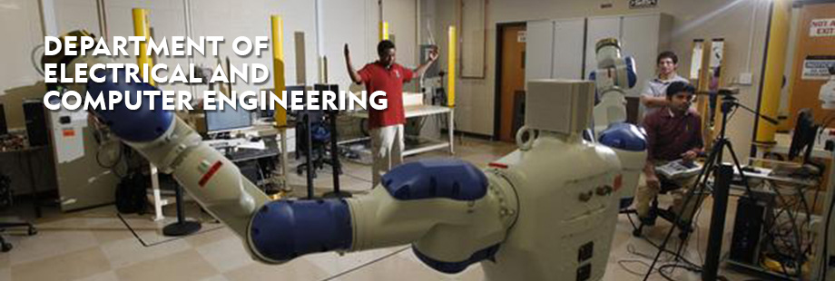

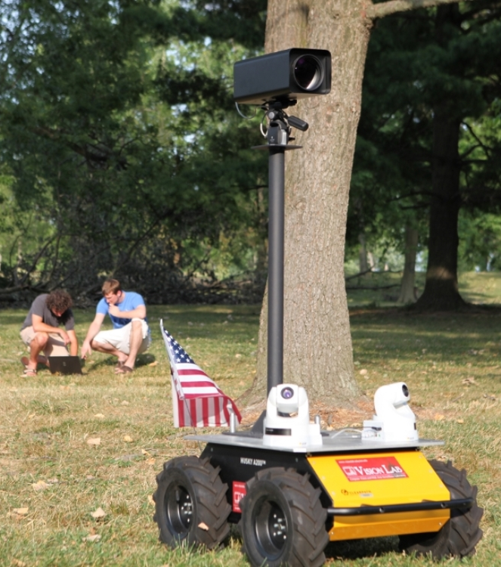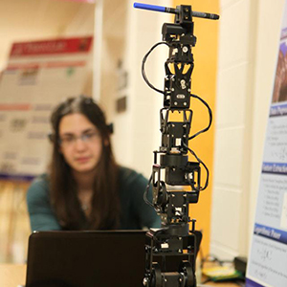

Webpage
https://udayton.edu/engineering/departments/electrical_and_computer/index.php.
Academic Catalog http://catalog.udayton.edu/undergraduate/schoolofengineering/programsofstudy/electricalandcomputerengineering/#BACH_OF

Our electrical and computer engineering undergraduate programs are accredited by the Engineering Accreditation Commission of ABET, http://www.abet.org.
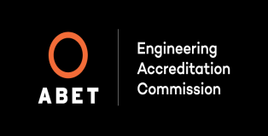

Table of Contents
Introduction to the Department of Electrical and Computer Engineering 3
Highlights of Electrical and Computer Engineering at UD 3
Top 10 Reasons to Pick ECE Major at UD 4
Quotes from ECE Alumni 4
About the Department 6
Contact Information 6
Address 6
Contacts 6
Advising 6
Our Mission 6
Programs of Study (What courses do I take?) 6
Electrical Engineering Program Objectives 7
Computer Engineering Program Objectives 8
Common Academic Program Requirements 8
Technical Electives 9
Electives for ELE Program 9
Electives for CPE Program 9
Concentrations 10
Concentration in Robotics & Electrical Energy Systems 10
Undergraduate ECE Courses 10
Cooperative Education 10
5 Year B.S. + M.S. Accelerated Program (Bachelor’s + Masters) 11
Graduate School 11
Graduate Concentration Areas 11
Useful Websites 12
Faculty 13
Bachelor of Electrical Engineering Flow Chart 17
Bachelor of Science in Computer Engineering Flow Chart ………………...…………………………18

Introduction to the Department of Electrical and Computer Engineering

The Department of Electrical and Computer Engineering (ECE) at the University of Dayton offers world-class programs leading to the degrees of Bachelor of Electrical Engineering and Bachelor of Science in Computer Engineering. Both degrees are accredited by the Accreditation Board for Engineering and Technology (ABET). Electrical and Computer Engineering is one of the broadest areas in engineering. According to the U.S. Dept. of labor, nearly 45% of all engineering done in the U.S. is in the field of Electrical and Computer Engineering! Electrical and Computer Engineer’s enjoy the top (or nearly the top) salaries in engineering at all education levels. Electrical and Computer engineering includes topics such as biomedical/bioengineering, computer hardware and software, computer vision, digital system design and integrated circuit design, electro-optics, robotics and controls, sensor technologies, signal and image processing, telecommunications and wireless systems, and wide area surveillance. The Dayton area is a high-tech research and development community, and our faculty work with nearby Wright-Patterson Air Force Base (WPAFB), Air Force Research Laboratories (AFRL), and numerous aerospace, automobile, sensor systems, and information technology companies. The UD campus is home to the $53 million General Electric Electrical Power Integrated Systems Center (EPIS), with close ties to our department. In addition to state-of-the-art teaching labs, we have a number of exciting specialty labs such as the Vision Lab, Integrated Microsystems Lab, High Performance Computing Lab, Embedded Systems Lab, Applied Sensing Lab, and the Yaskawa Motoman Robotics lab, and numerous faculty research labs with active undergraduate research projects. Our department faculty include world-renowned teachers and researchers who have authored textbooks, published extensively in prestigious journals and conferences, and are Fellows in their respective professional organizations. We pride ourselves on our world-class curriculum, which is updated regularly to meet the changing needs of government, industry, and academia. We offer more hands-on lab classes than other engineering majors, and these utilize our state-of-the-art laboratory facilities.

Highlights of Electrical and Computer Engineering at UD

ECE provides world-class ABET accredited curricula for Electrical and Computer Engineering degrees that rivals any top program around the country. ECE offers concentrations in electro-optics, robotics, and electrical energy systems.
Our graduates are consistently well placed in government and industry. Nationally and locally, there are more jobs than expected graduates. The average annual salary offer for ELE and CPE graduates from UD is well above the national average.
ECE students are consistently placed in top graduate programs including Stanford, University of Illinois-Urbana, University of Michigan, Purdue University, Ohio State University, Penn State University, University of Maryland-College Park, University of Tennessee, University of Florida, Drexel University, UC-San Diego, Georgia Tech, Northwestern, John Hopkins and the University of Dayton as well.
ECE pioneered a Five-Year B.S.+M.S. accelerated degree program for qualified undergraduate students. By taking two approved graduate courses in the senior year as technical electives, one can complete the M.S. degree in as little time as one additional academic year at discounted tuition rate. This program is available to both ELE and CPE undergraduate majors.
ECE supports a strong co-op program with student placements in many top local and national companies. Extensive research opportunities with University of Dayton Research Institute (UDRI) and WPAFB also give students hands-on research experience as undergraduates. There are many co-op schedules available.
ECE maintains state-of-the-art laboratories that support a hands-on approach to education. We continually renovate and enhance all of our classroom teaching labs. We have numerous research labs to support research programs in advanced digital design, embedded systems, computer vision, control systems, signal and image processing, electro-optics, microelectronics, nanotechnology, robotics, biomedical and microwaves.
ECE offers a comprehensive set of technical electives and an interdisciplinary capstone design experience with the innovation center, working on real-world industry sponsored projects.

Top 10 Reasons to Pick ECE Major at UD

- Great careers that command top salaries (see Bureau of Labor Statistics).
- Broad-based curriculum prepares you for all areas of ECE. Both Electrical Engineering and Computer Engineering curriculum is accredited by ABET.
- More technical electives & lab courses than other engineering majors, plus hot concentration areas (electro-optics, robotics, electrical energy systems, and the planned bioengineering concentration).
- Top notch facilities and faculty (recent UD award winners in both teaching and scholarship).
- Small classes allow lots of personalized attention.
- Excellent job, co-op and graduate school placement, in addition to a well-structured co-op program.
- Plenty of design experiences including capstone design with innovation center working on real-world projects sponsored by industry.
- 5-year BS/MS degree program and an “MBA ready” program.
- Funded undergraduate and graduate research opportunities.
- Fun, cutting edge field that plays a major role in service to modern society.

Quotes from ECE Alumni

- "I have nothing but positive things to say about the electrical and computer engineering department at UD. The material taught in lecture is intellectually stimulating and it is evident that the professors are experts in their respective fields. Smaller class sizes really allow students to interact with one another and provides a more engaging learning experience. In addition, students are able to develop much more personal and professional relationships with their professors. The 5-year BS/MS degree program allows students to explore their research interests while improving their overall engineering skills. After completing both the undergraduate and graduate Computer Engineering programs, I owe a lot to the ECE department for shaping me into the individual and engineer I am today.” ~ Bradley Sorg, BSCPE 2017, MSCPE 2018

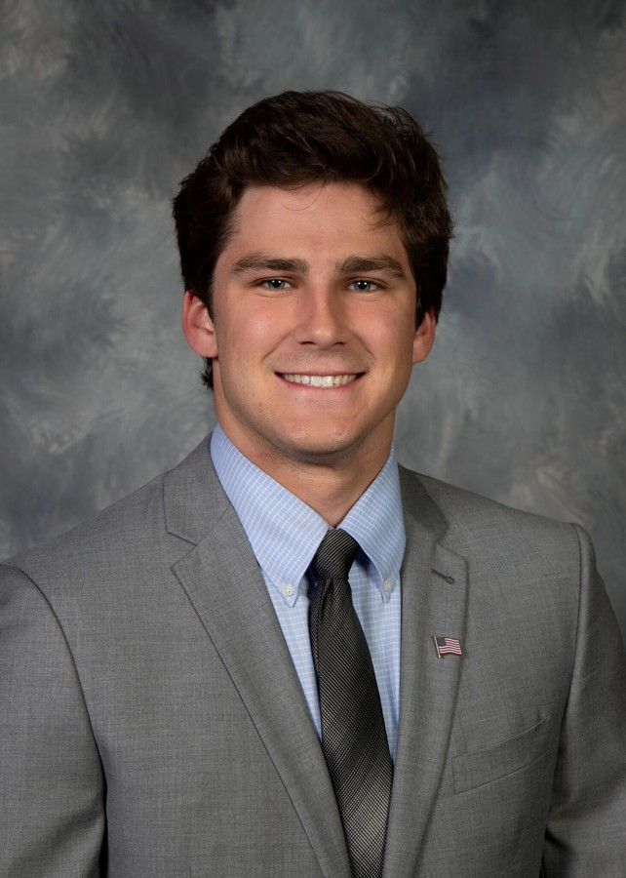
- “Being from Kansas City, I always find people asking me why I chose Dayton before college started. Now that I have experienced the wonders of UD, I can proudly talk for a while about why I love this school, and I always talk in depth about the ECE department. I knew going into college how strong UD was in research, internship and co-op opportunities, and taking care of each student, but actually experiencing this and seeing how it’s not anywhere close at other schools makes me know my choice was a great one. Classes were great because my teachers care. They enjoy having us in class, they make bonds with us as we progress in classes and become our advisors. Labs for ECE students are an exceptional tool to learn the material in a deeper and different way. On top of all of this, the opportunities to get involved with engineering based learning and hands-on programs give students a chance to try out new fields while advancing their experience. Traveling to Guatemala for Dayton’s ETHOS program was life changing and taught me practical knowledge and helped advance my electrical engineering curriculum in ways classes do not normally have the chance to. Taking on leadership roles in the Institute of Electrical and Electronic Engineers (IEEE) taught me how to run a group of over 150 students, plan for events with outside companies and speakers, and even help other groups plan for much bigger events and symposiums. When people ask how I decided what college I wanted to go, now I can look back, laugh and think of how lucky I was to end up at UD.” ~ Blaise Gassman, BEE 2019

- I changed my major to Computer Engineering at the beginning of my sophomore year and immediately knew it was the right decision. I felt supported by the faculty in all of my coursework and was encouraged to get involved in extracurriculars outside the classroom. The ECE/CPE program was formed very intentionally – with concept-based courses your freshman and sophomore year and more project-based courses junior and senior year. I believe that this curriculum has provided me with some real-world experience that has prepared me for my career. This program has not only prepared me academically, but has also given me opportunities to advance professionally – through conferences, workshops, and speakers. UD’s Electrical and Computer Engineering department has given me the tools I need to be successful after graduation. ~ Anne Fitz, BSCPE 2019 (Will be working as a Product Engineer at Esri)
- The engineering program is the reason I picked UD. I could tell the engineering faculty and staff really cared for their students and helped them achieve their goals. Through my years as an ECE undergrad, I have grown into a better student, a better team member, and over-all a better person. I have learned more than I ever thought was possible and have been offered opportunities that I never could have dreamed of because of the knowledge and experience I have gained through this department. I have also created relationships with faculty members and students that will last a lifetime. I am excited to stay for my Master’s in ELE and see where this education leads me next! ~ Monica Yeager, BEE 2019

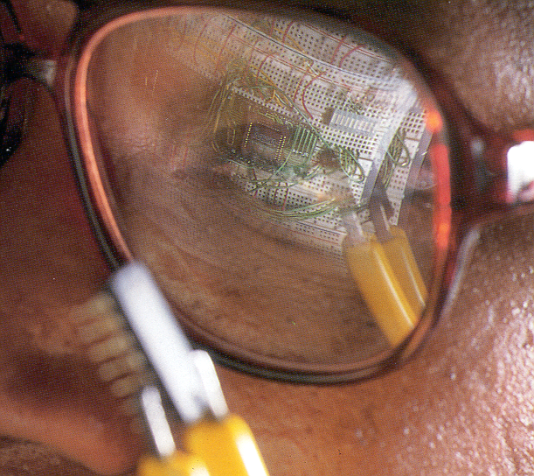
About the Department

The Department of Electrical and Computer Engineering (ECE) offers two ABET accredited undergraduate degree programs: the Bachelor of Electrical Engineering program and the Bachelor of Science in Computer Engineering program.

Both electrical engineering (ELE) and computer engineering (CPE) are broad-based engineering disciplines that provide for a wide range of career choices within the engineering field. They also provide an excellent basis for careers in such diverse areas as business, law, and medicine.

Contact Information

Address

University of Dayton
School of Engineering
Department of Electrical and Computer Engineering
Kettering Laboratories Room 266
300 College Park
Dayton, OH 45469-0232

Phone: 937-229-3611
Fax: 937-229-4529

Contacts

Dr. Eric Balster, Chairperson
E-mail: ebalster1@udayton.edu
Ms. Nancy Striebich, Administrative Assistant
Email: nstriebich1@udayton.edu

Advising

During their first three years, students are advised by a team of advisors in the School of Engineering Office of Student Success. Once the student has achieved senior standing, s/he will have a faculty advisor assigned to them within the ECE department. All course registration, drop/add, minor/concentration selection, and other such activities require approval of the academic advisor. In case an advisor is unavailable and the matter cannot be delayed, the student should make an appointment to consult the ECE chairperson.

Our Mission

Our mission is to provide an educational experience of the highest quality to produce the discipline’s most valued graduates, with the skills and knowledge to learn, lead, and serve in electrical and computer engineering related professions and in their communities.

Programs of Study (What courses do I take?)

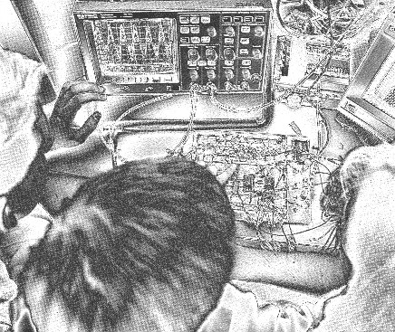
The official programs of study for ELE and CPE are provided in the Academic Catalog. However, one helpful way to understand the programs is with the course flow charts provided at the end of this document (one for ELE and one for CPE). Each column is an academic semester and each block represents a course. Prerequisites are indicated by the solid lines connecting courses, and these must flow from left to right. Co-requisites are courses that must be taken at the same time. These include all of our lab courses and this is designated on the flow charts with a dashed line connecting the courses. The lab courses must be taken with the corresponding course (unless a course or lab is being taken for a second time). Some departures from the courses listed in the programs of study are allowed. For example, approved transfer credits or AP credits may be used as substitutions. Any changes to the standard program must be approved by the department Chair.
Note that the curricula may change from one academic year to another. Know that the academic year in which you enter the program defines the course requirements for your degree. Thus, make sure you consult the flow chart labeled with the same academic year in which you enter (an archive of flow charts by date is available on the ECE website). You can monitor your progress towards your degree with the DegreeWorks tool that can be accessed from the Porches website under the Flyer Student Services tab. Registration for courses is done online and can be accessed through Porches. A numerical registration code is needed each semester from your faculty advisor to sign up for classes. Email your advisor and make an appointment to address any question and to receive your code.

Electrical Engineering Program Objectives

The undergraduate ELE curriculum is designed to provide an understanding of basic electrical engineering principles with emphasis on the development of problem-solving skills. An extensive laboratory experience is integrated with the classroom work to assure that the student develops a working knowledge of fundamentals. In addition to including electrical engineering breadth, the curriculum allows students to explore depth in selected topic areas/concentrations. Upper level courses integrate the knowledge base with current technology and tools resulting in a graduate capable of contributing to the engineering profession by either entering the work force or pursuing a graduate level education.

Our specific educational objectives are that our alumni will:

- Find rewarding careers as engineering professionals, as electrical engineers they will design and develop new products, technologies and processes that incorporate one or more of the following elements: analog and digital circuits, signals and systems, propagation and processing of signals, and control systems.
- Continue their professional education either formally, in graduate school, professional schools, or through industrial training programs; or informally through activities such as continuing education, attendance in short courses, professional workshops and conferences.
- Exercise and further develop their skills in professional communications through activities such as project briefings, conference presentations, technical reports and manuals and journal publications.
- Participate in activities for the betterment of society and carry on the traditions of the University of Dayton by maintaining high ethical standards in their professional activities, and by serving their country and community through service, leadership and mentorship.

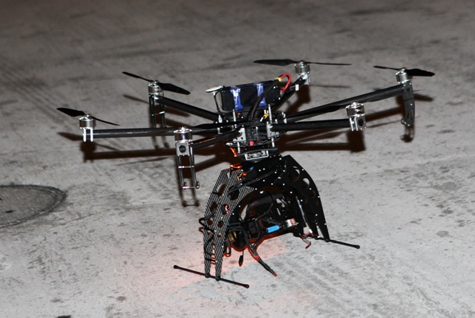
Computer Engineering Program Objectives

The undergraduate CPE curriculum is designed to provide an understanding of basic computer engineering principles with emphasis on the development of problem-solving skills. The basic software aspects of computer engineering are introduced in the very first year while hardware and hardware-software integration topics are emphasized starting in the sophomore year. An extensive hands-on laboratory experience is integrated with the classroom work to assure that the student develops a working knowledge of the fundamentals.

Our specific educational objectives are that our alumni will engage in:

1. The design and development of new products, technologies and processes that incorporate one or more of the following elements: analog and digital circuits, signals and systems, computer design, software development, and hardware/software integration;

2. Professional development through activities such as continuing education, attendance in short courses and/or conferences, professional workshops, and graduate school;

3. Professional communications through activities such as project briefings, conference presentations, technical reports and manuals, and journal publications;

4. Service, leadership and mentorship roles in their profession and community.

Common Academic Program Requirements

The ELE and CPE programs include university level Common Academic Program (CAP) requirements, as well as engineering related topics. CAP requirements are satisfied by the courses shown on the flow chart with a red outline. These CAP-fulfilling courses include the Humanities Commons:

- HST 103
- PHL 103
- REL 103
- ENG 100 and ENG 200
- CMM 100
- SSC 200

Some courses that are part of the required technical program of study also jointly serve to satisfy CAP requirements. These include the following:

- MTH 168
- PHY 206
- CHM 123
- PHY 210L
- ECE 432L

The remaining CAP requirements are fulfilled with what we refer to as the CAP electives (as there are multiple ways for students to fulfill these). There are a total of three CAP elective courses needed as shown on the flow charts. These 3 courses must include the following:

- Arts Elective
- Advanced Historical Study
- Advanced Philosophy or Religious Study

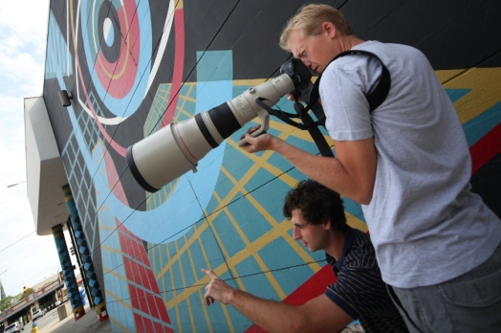
It is important that students take care to select these 3 courses so as to successfully complete the 2 CAP attributes of Faith Traditions and Diversity and Social Justice. Note that all other CAP requirement are satisfied by the required curriculum and do not need to be considered when picking CAP electives. The CAP requirements satisfied by various courses are listed on the CAP page:. http://www.udayton.edu/provost/cap/
The easiest way to ensure that you fulfill the CAP requirements is by using the ECE CAP Calculator: https://www.udayton.edu/engineering/departments/electrical_and_computer/undergrad_computer/student_resources.php. You can double-check your course selection by using the “What if” feature in DegreeWorks (accessed from Porches).

Technical Electives

Electives for ELE Program

Electrical Engineering students are required to choose two ECE courses, 300 level and above, that are not required courses in the program as ECE technical electives. They must choose two more engineering science technical electives from the following list.

- Any 6 semester hours of coursework, 300 level and above, in: ACC, BIO, CEE, CHM, CME, CPS, ECO, ECE, EGM, EGR, ENM, EOP, FIN, IET, INB, ISE, MBA, MED, MEE, MGT, MIL, MIS, MKT, MSC, MTH, OPS, PHY, PLW, POL, SEE
- Required courses in degree program do not count as technical electives

- Exceptions:
- CME 452 Process Control
- IET 490 Senior Project
- IET 493 Honors Thesis
- IET 494 Honors Thesis
- MEE 314 Computational Methods
- MEE 432L Multidisciplinary Engineering Design Lab II
- MEE 439 Dynamic Systems and Controls
- MTH 367 Statistical Methods I
- MTH 368 Statistical Methods II
- MTH 395 Development of Mathematical Ideas
- MTH 411 Probability and Statistics

Electives for CPE Program

Computer Engineering students are required to choose two ECE or CPS courses, 300 level and above, that are not required courses in the program as CPE technical electives. They must choose one more engineering science technical electives from the following list.

- Any 3 semester hours of coursework, 300 level and above, in: ACC, BIO, CEE, CHM, CME, CPS, ECO, ECE, EGM, EGR, ENM, EOP, FIN, IET, INB, ISE, MBA, MED, MEE, MGT, MIL, MIS, MKT, MSC, MTH, OPS, PHY, PLW, POL, SEE
- Required courses in degree program do not count as technical electives
- Exceptions:
- IET 490 Senior Project
- IET 493 Honors Thesis
- IET 494 Honors Thesis
- MEE 314 Computational Methods
- MEE 432L Multidisciplinary Engineering Design Lab II
- MTH 367 Statistical Methods I
- MTH 368 Statistical Methods II
- MTH 395 Development of Mathematical Ideas
- MTH 411 Probability and Statistics
Note: Pre-requisites may be required for some technical elective courses. Additional technical electives may be approved by the ECE department Chair.

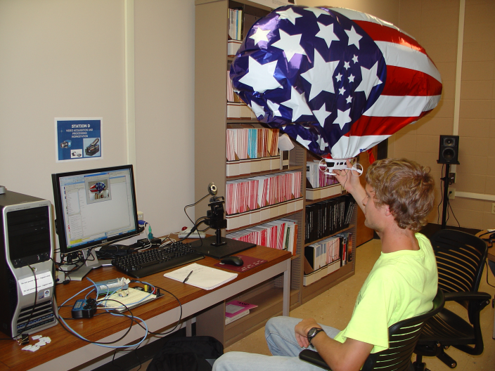
Concentrations

A concentration is a specialization within your major. This is not to be confused with a minor. Minors are offered by other departments outside of your major department. You should contact the department in which the minor is offered for more information.

Concentration in Robotics
The department of Electrical and Computer Engineering offers a concentration in Robotics available to ECE students. ELE students can complete the concentration using available technical electives, while CPE students need one additional course outside the required technical electives. The concentration has five courses: three required and two from a set of electives.

Courses Required:

ECE 415 Control Systems (Note: this is already required for ELE students)

ECE 416 Introduction to Robotics

ECE 447 Digital Controls

Any two from:
ECE 414 Electro-Mechanical Devices
ECE 444 Advanced Digital Design
ECE 445 Signal Processing
MEE 321 Theory of Machines
MEE 434 Mechatronics
MEE 438 Robotics & Flexible Manufacturing
CPS 480 Artificial Intelligence

Concentration in Electrical Energy Systems
The Electrical Energy Systems Concentration (EES) will prepare our Electrical and Computer Engineering students all aspects of Electrical Energy Systems including generation, transmission, distribution, utilization, storage, as well as enabling technologies for the smart grid.

Courses Required:
ECE 316/499 Intro. To Electrical Energy Systems
ECE 414 Electro-Mechanical Devices
ECE 471 Contemporary Power Systems

Any one from:
ECE 472 Smart Grid Technologies
MEE 473 Renewable Energy Systems

Undergraduate ECE Courses

A full list of ECE courses can be found in the course catalog:

http://catalog.udayton.edu/allcourses/ece/

Additional Opportunities

Cooperative Education

Cooperative (co-op) education is an optional program in which both ELE and CPE students are eligible to participate as long as the students maintain good academic standing. It enables students to blend classroom theory with practical experience in their chosen field. Placement in a co-op job is not guaranteed since it depends on the student’s qualifications and job availability. Students are encouraged to begin their first co-op work semester only after their third semester of academic study.

For information on co-op opportunities, contact the Cooperative Education Program office (KL 503):
- https://udayton.edu/engineering/connect/cooperative-education/index.php
Office of Cooperative Education
Kettering Labs Room 503
Phone: 937-229-2335 Fax: 937-229-2030

Before beginning the co-op program, the interested student is required to have a Work/Study Calendar form signed and approved by the ECE chairperson and the director of the Cooperative Education program.

5 Year B.S. + M.S. Accelerated Program (Bachelor’s + Masters)

https://udayton.edu/engineering/undergraduate/bachelors-plus-masters/index.php

This program, enables undergraduate ECE students with an engineering GPA of 3.0 or higher, to earn an M.S. degree within a year after their B.S. degree. Accelerated program students should take two graduate level courses (6 credit hours) from the list of approved technical electives. These two courses satisfy both undergraduate and graduate program requirements. Graduate students will then also take an additional 24 graduate credit hours to complete the M.S. degree requirements.

Concentration areas and courses in each area are listed in the Graduate Concentration Areas table on page 16. While all students are encouraged to do a thesis, students supported by an assistantship or tuition scholarships from the department (Graduate Teaching Assistantship, or Graduate Research Assistantship) are required to complete a thesis. The M.S. degree will be conferred at the successful completion of the graduate requirements. Note: A significant tuition discount is available for the Bachelors + Masters (BPM) students after the completion of undergraduate requirements.

Graduate School

Whether you take advantage of the 5 Year Bachelor’s + Master’s program or not, do consider graduate school. An M.S. degree is an excellent terminal degree in engineering as it raises salaries and provides significant professional advancement. It is also a step towards a Ph.D. degree for those with research and academic ambitions. Students with a high GPA are often able to obtain a full teaching or research assistantship to pay for graduate education with a stipend, tuition, and benefits. Our department offers excellent graduate programs in Electrical Engineering,
Computer Engineering, and Electro-Optics (with our close partner the Department of Electro-Optics
& Photonics). If you think you might be interested don’t hesitate to speak with your professors and/or the department chairperson. Our ECE undergraduates have consistently made excellent and successful graduate students (at UD and elsewhere). More information on graduate programs and resources for graduate students is available on the graduate section of the ECE website

Graduate Concentration Areas
Sensors and Devices | Signals and Systems | Computing Systems
Choose Three From:  Digital Communications I & II, Antennas, Microwave Engineering & Systems, Fourier Optics, Guided Wave Optics, Integrated Optics, Nanoelectronics, etc. | Choose Three From:  Digital Signal Processing, Image Processing, Statistical Signal Processing, Adaptive Signal Processing, Automatic Control, Nonlinear Systems and Control, Adaptive Control, Robotics, Computer Vision, Machine Learning, etc. | Choose Three From:  Computer Architecture, Micro-electronic Systems, Embedded Systems, Micro-processor Applications, Advanced Engineering Software, Neuro-morphic Computing, etc.

Useful Websites
School of Engineering
- https://udayton.edu/engineering/index.php
Electrical and Computer Engineering Homepage:
- https://udayton.edu/engineering/departments/electrical_and_computer/index.php
Academic Calendar
- https://udayton.edu/fss/important_dates/academic_calendar.php
Registration
- https://udayton.edu/fss/important_dates/registration-dates-and-times.php
Center for International Studies
- https://udayton.edu/international/isss/index.php
Learning Teaching Center
- http://www.udayton.edu/ltc/learningresources/
Counseling Center
- https://udayton.edu/studev/health_wellness/counselingcenter/index.php
Student Development (handbook, wellness, housing, etc.)
- http://www.udayton.edu/studev/
Common Academic Program
- http://www.udayton.edu/provost/cap/
Isidore Login:
- https://isidore.udayton.edu/portal
UD Library
- http://www.udayton.edu/libraries/
Career Services
- http://careers.udayton.edu
Co-op Office
- https://udayton.edu/engineering/connect/cooperative-education/index.php
ECE faculty and staff
- https://www.udayton.edu/engineering/departments/electrical_and_computer/faculty-staff/index.php

Department Related YouTube Videos
- Robotic Ball Catcher Project
https://www.youtube.com/watch?v=hBkPD41WBU

Faculty:

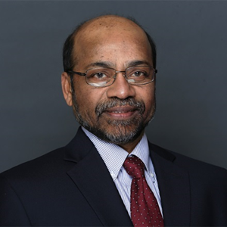
Vijayan K. Asari

Professor
PhD, Indian Institute of Technology, Madras, 1994
Areas of research interest:
Signal Processing, Image Processing, Computer Vision, Pattern Recognition, Machine Learning, Artificial Neural Networks, High Performance and Low-Power Digital Architectures

Biography: Dr. Vijayan Asari is the Ohio Research Scholars Chair in Wide Area Surveillance and Professor in Electrical and Computer Engineering at University of Dayton. Dr. Asari received his Bachelor's degree in Electronics and Communication Engineering from the University of Kerala, India in 1978, the M.Tech. and PhD degrees in Electrical Engineering from the Indian Institute of Technology, Madras in 1984 and 1994 respectively. He had been working as a Professor in Electrical and Computer Engineering at Old Dominion University, Virginia and joined UD in February 2010. Dr. Asari has so far published more than 260 articles including 55 journal papers in the fields of image processing, computer vision, pattern recognition, artificial neural networks, and high performance and low power digital architectures for image and video processing applications. His current research focus areas are wide area surveillance, biometrics, vision guided robotic navigation, brain wave analysis, and high performance and low power architecture design.

Eric J. Balster
Professor, Chair
PhD, The Ohio State University, 2004
Areas of research interest:
Image and Video processing,
Software Engineering,
Digital Systems

Biography: Eric Balster graduated from the University of Dayton in 1998 with a B.S. and in 2000 with an MS, both in Electrical Engineering. He received his PhD in Electrical Engineering from The Ohio State University in June of 2004. His research area was in the field of image and video processing, specifically in compression and pre-processing algorithm development. From 2002 to 2006, Dr. Balster worked in the Information Directorate, Air Force Research Laboratory (AFRL), continuing his work in image and video processing research. From 2006 to 2008, he worked in the AFRL’s Sensor’s Directorate, serving as the lead aircraft software development and support engineer for a wide-area persistent surveillance program. Since August 2008, Dr. Balster has worked as an assistant Professor at the University of Dayton where he continues research in image processing and aerial surveillance processing research.

Dong Cao
Associate Professor and GE EPISCenter Professor
PhD, Michigan State University, 2012
Areas of research interest: Power Electronics, Wide Bandgap Device (SiC/GaN) application, Electrified Vehicle/Airplane, Motor Drive, Photovoltaic/Data Center health monitoring and lifetime prediction of power converters.

Biography: Dong Cao joined ECE Dept. in 2019 as GE EPISCenter Professor and an Associate Professor. He obtained his Ph.D. and M.S. degrees in Electrical Engineering from Michigan State University in 2010 and 2012, respectively. He received the B.S. degree from Zhejiang University, Hangzhou China, in 2005. He worked at Ford Motor Company as a core power electronics engineer for hybrid electric vehicle electrified driveline hardware development from Jan. 2012 ~ Jul. 2014. He was an assistant professor at North Dakota State University from Aug. 2014 to Aug. 2019. He has co-authored more than 70 refereed journals and conference proceedings, including 3 prize papers with 2000+ citations according to google scholar. He is the associated editor for the IEEE Journal of Emerging and Selected Topics in Power Electronics.

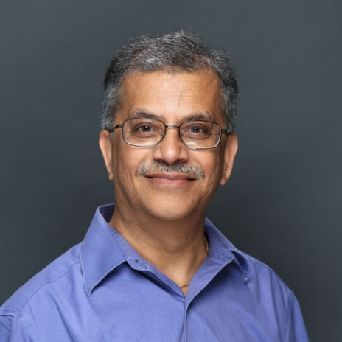
Monish Chatterjee
Professor
PhD, University of Iowa, 1985
Areas of research interest: Acousto-optics, optical bistability and chaos, holography, nonlinear system modeling, wave propagation

Biography: Monish R. Chatterjee received the B.Tech (Hons) degree in Electronics and Communications Engineering from I.I.T., Kharagpur, India, in 1979. He received the MS and PhD degrees, both in Electrical and Computer Engineering, from the University of Iowa, Iowa City, Iowa, in 1981 and 1985 respectively. Dr. Chatterjee served as a visiting faculty at the University of Iowa for one year before joining the ECE faculty at Binghamton University, the State University of New York, and conducted teaching and research from 1986 through 2002. In fall 2002, Dr. Chatterjee joined the University of Dayton’s ECE department Dr. Chatterjee has published numerous essays, correspondences, and three books of translation from his native Bengali. He received the State University of New York’s Chancellor’s Award for Excellence in Teaching in 2000. He is a Senior Member of IEEE, and a member of OSA, ASEE and Sigma Xi.

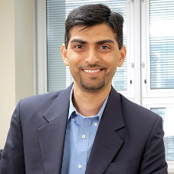
Vamsy Chodavarapu
Professor
PhD, State University of New York, Buffalo, 2006
Areas of research interest: CMOS Sensor Microsystems, RF/Analog Circuits, Neuro-/Biomedical- Implants and Wearables, Bio-/Neuro-/RF-MEMS, and Biological/Chemical Sensing

Biography: Vamsy Chodavarapu joined the ECE Dept. in 2015 as an Associate Professor. He obtained his Ph.D. and M.S. degrees in Electrical Engineering from University at Buffalo, The State University of New York in 2006 and 2003, respectively. He obtained his B. Eng. Degree in Instrumentation Engineering from Osmania University, India in 2001. From 2006 to 2015, Chodavarapu was a faculty member in the Dept. of Electrical & Computer Engineering at McGill University, Montreal, Quebec, Canada. Since 2011, he is a full licensed Professional Engineer in the Province of Ontario, Canada. He has co-authored more than 90 refereed journals and conference proceedings. He has 8 approved/pending United Stated patents. He is a Senior Member of both SPIE and IEEE.

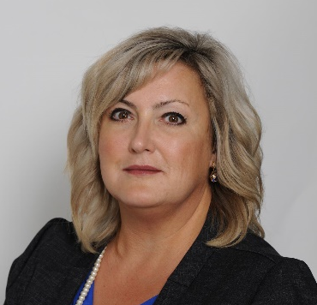
Amy Doll
Associate Professor
PhD, Wright State University
1993
Area of research interest: neuro-muscular rehabilitation, bio-sensors and instrumentation, wearable electronics, additive manufacturing, adaptive human computer interfaces, human performance/ control engineering, medical imaging, robotics, orthopedic biomechanics, and biomaterials.

Biography: Dr. Amy Doll joined the University of Dayton in 2017. She obtained her PhD, MS, and BS in Biomedical Engineering from Wright State University in Dayton, OH (2003, 1994, and 1993, respectively). Dr. Doll is a registered Professional Engineer in the State of Ohio in Mechanical Engineering (1998-Present), and has over 15 years of experience in biomedical engineering. She holds a certificate in Universal Design for Learning from George Washington University (2010), and Architecture and Systems Engineering from the Massachusetts Institute of Technology (2016). Prior to her appointment at the University of Dayton, Dr. Doll served as the Director of Rehabilitation Engineering & Technology at Wright State University Research Institute, where she also held a joint teaching appointment in the Department of Biomedical, Industrial and Human Factors Engineering. She has over 16 years of clinical experience in healthcare management of biomedical technology for the State of Ohio, as well as aerospace medicine through microgravity research with NASA.

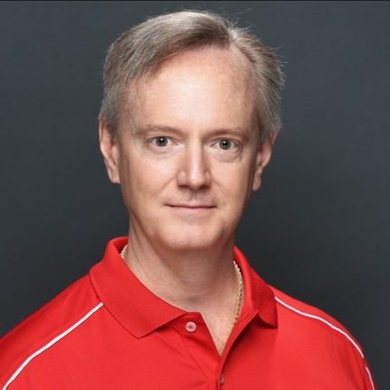
Bradley D. Duncan
Professor
PhD, Virginia Tech, 1991

Areas of research interest: Ladar system analysis and design, fiber optic sensing/communications, optical waveguide transmission applications, photorefractive device and system design, scanning and nonlinear optical image processing, non-destructive evaluation and holography.

Biography: Bradley D. Duncan received the Bachelor of Science in Electrical Engineering (BSEE) Degree in 1986 from Virginia Tech. He received the MS and PhD degrees in Electrical Engineering, also from Virginia Tech, in 1988 and 1991 respectively. Dr. Duncan has been with the University of Dayton since August 1991. He holds a joint appointment with the Department of Electrical & Computer Engineering, and the graduate Electro-Optics Program. He is a Senior Member of IEEE.

Russell C. Hardie

Professor

PhD, University of Delaware, 1992
Areas of research interest: Digital Signal and Image Processing, Statistical Signal Processing, Pattern Recognition, Medical Image Processing.

Biography: Russell C. Hardie graduated Magna Cum Laude from Loyola College in Baltimore Maryland in 1988 with a B.S. degree in Engineering Science. He obtained an MS and PhD degree in Electrical Engineering from the University of Delaware in 1990 and 1992, respectively. Dr. Hardie served as a Senior Scientist at Earth Satellite Corporation in Maryland prior to his appointment at the University of Dayton in 1993. He is currently a Full Professor in the Department of Electrical and Computer Engineering and holds a joint appointment with the Electro-Optics Program. Along with several collaborators, Dr. Hardie received the Rudolf Kingslake Medal and Prize from SPIE in 1998 for work on multi-frame image resolution enhancement algorithms. Dr. Hardie recently received the University of Dayton’s top university-wide teaching award, the 2006 Alumni Award in Teaching. In 1999, he received the School of Engineering Award of Excellence in Teaching at the University of Dayton and was the recipient of the first annual Professor of the Year Award in 2002 from the student chapter of the IEEE at the University of Dayton. His research interests include a wide variety of topics in the area of digital signal and image processing. His research work has focused on image enhancement and restoration, pattern recognition, and medical image processing. He is currently a senior member of IEEE.

Keigo Hirakawa
Professor
PhD, Cornell University, 2005
Areas of research interest:
Signal and Image Processing, Statistics, Color Image Processing, Digital Camera Processing Pipeline, 3D Image Reconstruction and Display

Biography: Prof. Hirakawa has published in the literature of engineering, computer science, and statistics. He has received a number of recognitions, including a paper award from IEEE and keynote speeches at IS&T CGIV, PCSJ-IMPS, and CSAJ. He has strong track record of collaborating with industry partners. His book, "Digital Camera Processing Pipeline" is scheduled to be published by John Wiley & Sons Inc next year. His research focuses on algorithmic development of image processing, computer vision, biomedical imaging, and sensor designs. He is best known for his expertise in digital camera designs, and his contributions span color science, estimation theory, statistical modeling, and wavelet theory.

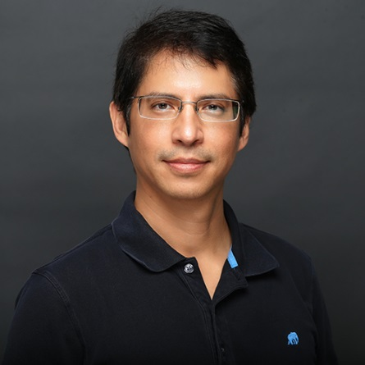
Raúl Ordóñez
Professor
PhD, Ohio State University, 1999
Areas of research interest: Control systems, nonlinear and adaptive control, robotics, multi-vehicle coordination, aircraft control and other control applications

Biography: Raul Ordonez received his M.S. and Ph.D. in electrical engineering from the Ohio State University in 1996 and 1999, respectively. He spent two years as an assistant professor in the department of electrical and computer engineering at Rowan University, and then joined the ECE department at the University of Dayton, where he has been since 2001 and is now a full professor. He has worked with the IEEE Control Systems Society as a member of the Conference Editorial Board of the IEEE Control Systems Society since 1999; Publicity Chair for the 2001 International Symposium on Intelligent Control; member of the Program Committee and Program Chair for the 2001 Conference on Decision and Control; Publications Chair for the 2008 IEEE Multi-conference on Systems and Control. Dr. Ordonez is also serving since 2006 as Associate Editor for the international control journal Automatica. He is a coauthor of the textbook Stable Adaptive Control and Estimation for Nonlinear Systems: Neural and Fuzzy Approximator Techniques, (Wiley, 2002); he is also co-author of the research monograph Extremum Seeking Control and Applications - A Numerical Optimization Based Approach, (Springer, 2011). He worked between 2001 and 2007 in the research team of the Collaborative Center for Control Science (CCCS), funded by AFRL, AFOSR and DAGSI at the Ohio State University. Dr. Ordóñez received a Boeing Welliver faculty fellowship in 2008, and an AFRL Summer Faculty Fellowship in 2014. He spent the summer of 2015 as a visiting professor at the Université de Picardie Jules Verne, with the Laboratoire M.I.S. (Modélisation, Information et Systèmes), in Amiens, France.

Bradley M. Ratliff
Associate Professor
PhD, The University of New Mexico, 2004
Areas of Interest: Image Processing, Machine Learning, Remote Sensing, Hyperspectral and Polarimetric Imaging

Biography: Brad Ratliff graduated from the University of Dayton in 2000 with a B.S. in Computer Engineering and 2001 with a M.S. in Electrical Engineering. He received his Ph.D. in Electrical Engineering from the University of New Mexico in 2004. His research areas was in the area of infrared imaging systems, specifically in the development of automated restoration algorithms to remove fixed pattern. After graduate school Dr. Ratliff pursued a start-up company based upon his graduate research, eventually licensing the technology to BAE Systems. He then transitioned back to the Dayton area and worked at Space Computer Corporation developing processing and exploitation algorithms for hyperspectral imaging systems. He then transitioned to the University of Dayton Research Institute in 2015 where he began teaching in UD’s Electrical and Computer Engineering Department. In the Fall of 2019 he accepted a full time position as an associate professor in UD’s Department of Electrical and Computer Engineering where he is working to build a research program based in algorithm development for infrared, hyperspectral, and polarimetric imaging systems for remote sensing applications.

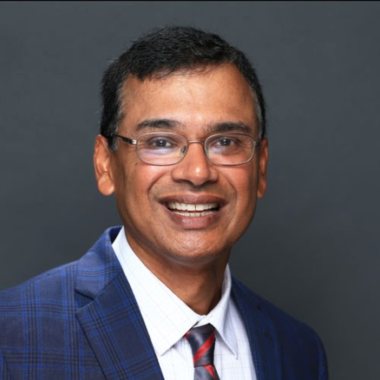
Guru Subramanyam
Professor
PhD, University of Cincinnati, 1993
Areas of research interest: Electronic & Electro-optic Materials, Devices and Sensors, and Microwave Circuit Design.

Biography: Guru Subramanyam received the Bachelor of Engineering Degree in Electrical and Electronics Engineering from the University of Madras in 1984, with Distinction. He received the MS and PhD degrees in Electrical Engineering from the University of Cincinnati, in 1988 and 1993 respectively. Prior to joining UD, he served as a faculty member at the University of Northern Iowa, Cedar Falls, Iowa from August 93 to May 98. He is currently a Senior Member of IEEE. His research to date has been supported by NASA, NSF, AFRL, AFOSR, and DARPA. He received UD’s Alumni Award for Excellence in Scholarship in 2008. Dr. Subramanyam’s research in integrated ferroelectrics, integrated microsystems and energy storage have resulted in many patent filings. He had authored/co-authored over 170 publications.

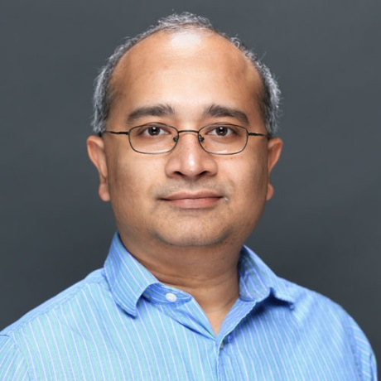
Tarek Taha
Professor
PhD, Georgia Institute of Technology, 2002
Areas of research interest:
Computer Architecture, Novel Computing Systems for Neuromorphic systems, High Performance Computing

Biography: Dr. Tarek M. Taha received the B.S. degree in pre-engineering from Depauw University, Greencastle, in 1996, and the B.S.E.E., MSE.E., and Ph.D degrees in electrical engineering from the Georgia Institute of Technology, Atlanta, in 1996, 1998, and 2002, respectively. He received the NSF CAREER Award in 2007 and is a member of the IEEE Computer Society.

Staff:

Penny Timmer
Lab Manager
B.S. Electrical Engineering,
Michigan State University, 1998

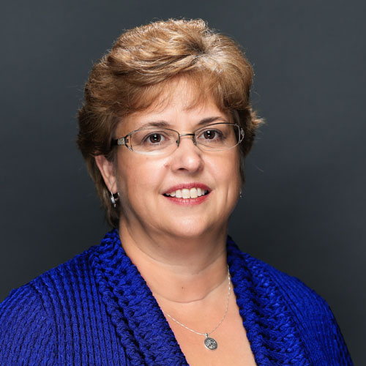
Nancy Striebich
Senior Administrative Assistant
B.S. University of Dayton, 1983

Bachelor of Electrical Engineering Flow Chart
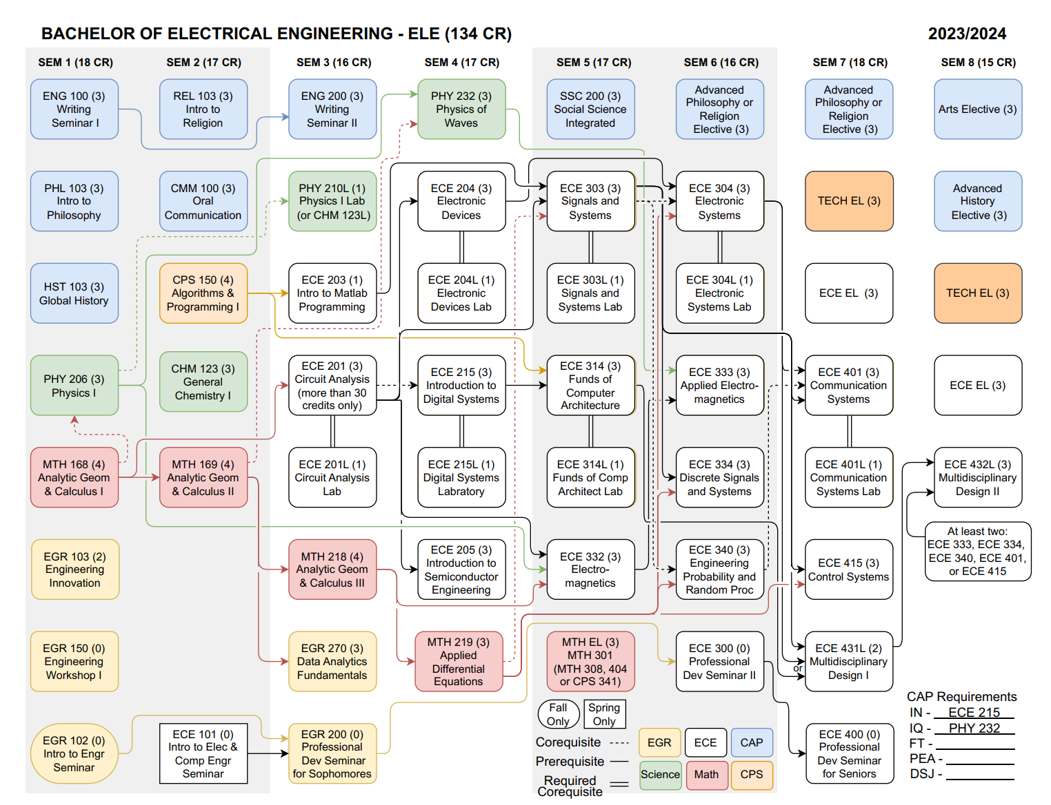
Bachelor of Science in Computer Engineering Flow Chart
