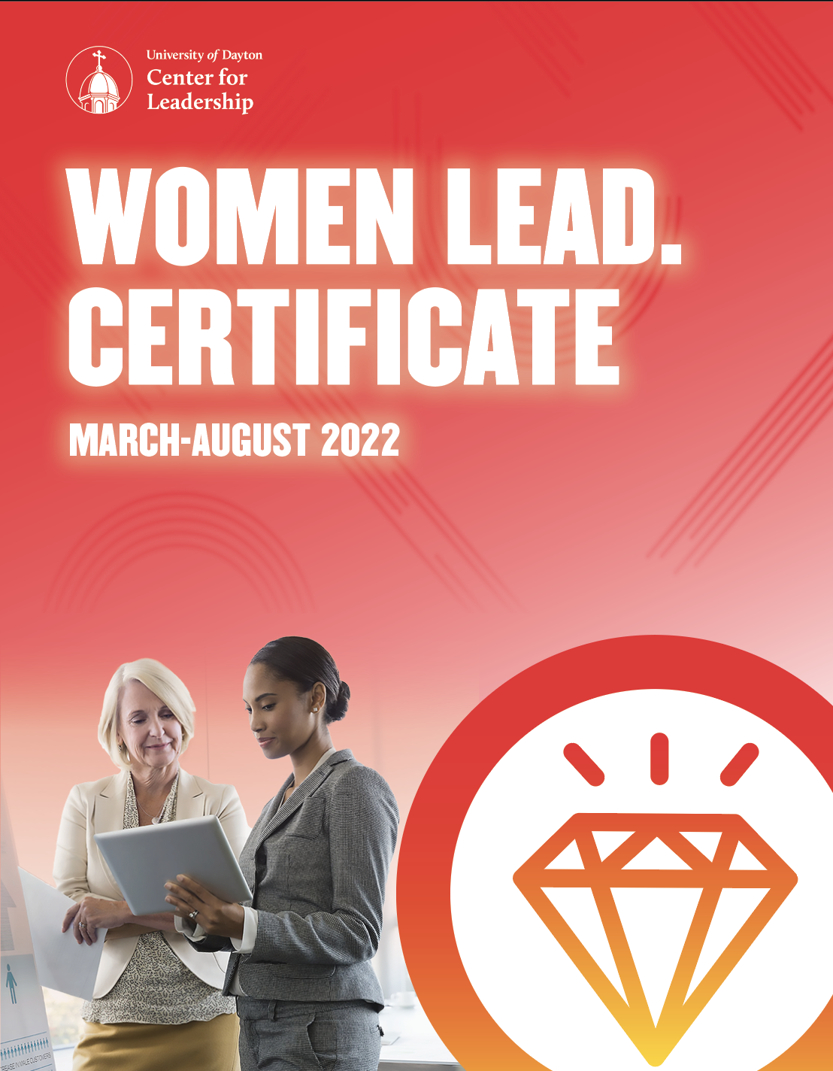
2021

PROGRAM BENEFITS

BUILD YOUR LEADERSHIP SKILLS: Fine-tune your critical leadership competencies while engaging in introspection and honing your power and influence. By examining the external and internal factors impacting you as a leader, you’ll take your leadership to the next level.

IDENTIFY & CULTIVATE YOUR STRENGTHS: Linkage’s Advancing Women Leaders (AWL) 360° Assessment will provide honest feedback on your leadership style, your strengths, and where you have opportunities for growth.

NETWORKING & ADVISORS: You will meet, connect, and learn from the strong and successful women in the room, developing a rich peer support network.

PASSIONATE & EXPERIENCED FACILITATORS: Women Lead. facilitators have diverse backgrounds in leadership, education, and experience to provide engaging sessions that will equip you with tools to take back to your workplace and assist in navigating your career.

CONTINUE TO BE INSPIRED: Following your Women Lead. experience, you are invited to join us back at the Center for Leadership for an Executive Program of your choice.

2022 CALENDAR

Date | Program
3/11 | PM: Your Field Guide to Women Lead.
3/31 | AM: Navigating Your Identity: Who You Are is How You Lead  PM: This Is Us! Identifying, Recognizing, and Leveraging the Value of ALL Leaders
4/13 | AM: Leveraging Mentorship for Growth
4/19 | (*choose between the two dates)  AM: Linkage’s Advancing Women Leaders (AWL) 360° Assessment Group Feedback Session
4/21 | PM: Linkage’s Advancing Women Leaders (AWL) 360° Assessment Group Feedback Session
5/12 | The Inner Game of Communication
6/8 | Supercharge Your Influence: Gain Power and Confidence – Next Level
6/30 | Managing Conflict and Difficult Conversations: Know Your Triggers
7/14 | Unleashing Your Inner Negotiator
7/26 | Designing Your Best Life: Create Your Personal Career Map
8/11 | Learn, Lead, and Serve
8/31 | Leadership & Work-Life Integration: The Hustle Without the Burnout
8/31 | Graduation

PROGRAM DESCRIPTIONS

Your Field Guide to Women Lead. | 3/11 PM 2:00 P.M.–4:30 P.M.
This program is your kick-off to a transformative leadership experience. During the course of the program, we will give you your field guide to Women Lead. A top priority for this program is beginning to develop powerful connections to other women leaders in your new learning ecosystem. We will also take a comprehensive look at how to maximize your success in the Women Lead. program through an informative look at the best practices and logistics necessary to equip you with exactly how you need to challenge yourself to be the most effective leader you can be.

Navigating Your Identity: Who You Are is How You Lead | 3/31 AM
9:00 A.M.–12:00 P.M.
The fundamental question of identity - “Who are you?” - is not always easily answered or accurately perceived. Many women feel the need to change something about themselves in order to fit in at work. In this program, you will talk candidly about what identity-management is necessary, what seems forced, and what may cause unnecessary stress. You will consider the basics of social identity, how women in leadership face inaccurate perceptions of their identity, and how an organization’s culture can make negotiating one’s own identity at work easier.

This program will help leaders:
- Learn and apply key components of social identity to better understand how your own sense of identity as a female leader influences your experiences at work.
- Consider ways in which your own preferences for disclosing identity and others’ perceptions of your identity influence your workplace relationships.
- Analyze your organization’s culture and inventory sources of support in navigating your own workplace identity.

Competencies Addressed: Situational Adaptability, Demonstrates Self-Awareness, Interpersonal Savvy, Self-Development, Values Differences

This Is Us! Identifying, Recognizing and Leveraging the Value of ALL Leaders | 3/31 PM 1:00 P.M.–4:00 P.M.
This Is Us! offers an innovative approach to connecting people—both personally and professionally. One of the best ways to ensure you are leading successfully is to be intentional about creating relationships. Although people often come together for a professional development experience that requires them to work in teams and collaborate on projects, an important element that is often overlooked is creating authentic opportunities for the participants to really get to know one another. While there is no shortage of programs that focus on team building, this session is designed to promote relationship-building.

As participants in the Women Lead. program seek to define and/or refine their personal and professional values, align their vision, mission and purpose, and prepare to grow and lead their organizations, each woman needs to feel connected and have a sense of belonging among her peers. When this is accomplished, team members will value, support, affirm, and appreciate one another. Through experiential learning promoting communication, cooperation, and collegiality, This Is Us! will allow participants to learn more about their cohort members while gaining a greater sense of appreciation for “who is in the room” and all that they bring.

This program will help leaders:
- Engage in an open and honest dialogue on the importance of creating a “sense of belonging” in our organizations, and as Women Lead participants.
- Gain skills to recognize and leverage diversity that will benefit, and be applicable as program participants—and as organizational leaders.
- Learn key leadership strategies that can be used to create inclusive organizational cultures and promote harmonious group dynamics among diverse team members, colleagues, and internal and external clients.

Competencies Addressed: Builds Network, Drives Engagement, Demonstrates Self-Awareness, Interpersonal Savvy, Values Differences

Leveraging Mentorship for Growth | 4/13 AM 9:00 A.M.–12:00 P.M.
In this program, you set a foundation for you and your mentor to discuss and leverage preferred styles of mentoring, the frequency of your meetings, and ensure that the strategies used in the coming mentoring meetings allow for career mapping and goal setting to be maximized. These advising sessions will give you the opportunity to build self-awareness on how your behaviors are perceived and what is needed to be recognized as a high impact leader.

This program will help leaders:
- Gain a unique understanding of how your mentor and you prefer to give and receive mentoring.
- Get insight and feedback from your mentor on a current leadership issue you are facing and develop a plan to address the issue.
- Set a schedule for sessions to begin to map out realistic goals to accomplish through the Women Lead. experience.

Competencies Addressed: Builds Network, Drives Engagement, Demonstrates Self-Awareness, Interpersonal Savvy, Self-Development

Linkage’s advancing women leaders (AWL) 360° AssesSment Group Feedback Session | 4/19 9:00–11:30AM | 4/21 1:00–3:30PM (*choose between the two dates)
Feedback and insight is key to self-awareness and improvement. Your Linkage’s Advancing Women Leaders (AWL) 360° Assessment report represents an opportunity to build self-awareness through a detailed examination of how your leadership behaviors are perceived. This introspective review will give you powerful tools for development through insights that cover your leadership strengths and areas of opportunity to continue to develop. You will leave the program with a framework to complete a development plan to share with your manager, mentor, and others to help improve your leadership and accountability.

This program will help leaders:
- Receive valuable feedback on your strengths and skills from your manager, direct reports, peers, and others.
- Start creating a development plan that will strategically assist you in maximizing your strengths and/or positively impacting your areas of opportunity.
- Understand how to implement your plan in order to maximize your success as a leader.

Competencies Addressed: Demonstrates Self-Awareness, Self-Development, Balances Stakeholders, Values Differences, Being Resilient
THE INNER GAME OF COMMUNICATION | 5/12 9:00 A.M.–4:00 P.M.
Effective communication is key to team and organizational performance, but most people in leadership roles struggle to communicate with clarity, conviction, and kindness. When it comes to tough conversations or communicating in the face of resistance, many people sugar coat, avoid altogether, clumsily land the message, or react defensively. This is especially true for women who often face extra challenges associated with stereotypes and biases that position them as either too “soft” or too “aggressive”. Traditional efforts to improve communication focus on models or strategies that, while valuable, overlook one key factor: the internal work that is needed to communicate in an effective way. Developing a powerful communication style requires we attend to important inner work such as perceptions, mindset, emotional responses, energy, and intentional practice. This session is designed to offer female leaders a guide to upgrading their inner game of communication so they can lead with clarity, conviction and kindness, and develop a culture of feedback on their teams.

This program will help leaders:
- Discover at least one personal “adaptive challenge” that currently limits your ability to communicate with impact.
- Identify and practice strategies for shifting mindset and emotions to overcome this adaptive challenge and foster more effective communication with others.
- Increase your ability to give and receive feedback courageously.

Competencies Addressed: Communicates Effectively, Drives Vision & Purpose, Drive Results, Persuades, Values Differences

SUPERCHARGE YOUR INFLUENCE: GAIN POWER AND CONFIDENCE – NEXT LEVEL
6/8 9:00 A.M.–4:00 P.M.
We all know what makes a leader special—right? It’s the way they carry themselves, their power and confidence to take charge of any situation, and their capacity to inspire, motivate, empower, and influence those around them. With today’s changing environment, it is essential to understand and know the tools to apply at every level in organizations to influence those around you to get things done. If you want to make a difference in your leadership — at work, at home, or in the community — you must understand how to maximize your leadership voice, power, and confidence. If you are ready to maximize your power and confidence and prepare to influence at the next level, this program is for you.

This program will help leaders:
- Understand the three different types of power and how to apply them to increase your capacity to inspire, motivate, and empower.
- Learn how to apply the three critical habits successful women leaders utilize to become more influential in any situation.
- Develop effective strategies to elevate your leadership voice and ability to influence others in an authentic way that gets results.

Competencies Addressed: Communicates Effectively, Drives Results, Interpersonal Savvy, Persuades, Organizational Savvy

Managing Conflict and Difficult Conversations: Know Your Triggers 6/30 9:00 A.M.–4:00 P.M.
Conflict and tough conversations can stall projects, create toxic cultures, and derail a woman’s career if improperly handled. Conflict erodes trust and costs organizations billions of dollars annually. Women may feel that they need to sidestep conflict and difficult conversations, however, this program will show how to successfully step into a conflict and difficult conversations with confidence.

This program will help leaders:
- Understand your triggers, and use a tool to identify conflict styles and how to use them effectively in the workplace.
- Practice how to prepare and handle difficult conversations with grace.
- Learn to build trust within teams to create a more positive work environment where positive conflict can lead to greater creativity.

Competencies Addressed: Communicates Effectively, Interpersonal Savvy, Values Differences, Builds Effective Teams, Manages Conflict

Unleashing Your Inner Negotiator | 7/14 9:00 A.M.–4:00 P.M.
Negotiation is a critical skill for women leaders, but most leaders haven’t been equipped with the essential tools to effectively negotiate. Multiple studies illustrate how a lack of confidence in negotiating is a detriment for most leaders. Do not let the fear of negotiating get you stuck! This program will help you understand the key aspects of how to successfully manage any type of professional and personal negotiation, whether that be a salary increase, leadership role request, etc. You will leave this program with stronger negotiation skills allowing you to better negotiate anything necessary and advocate strongly and decisively for what you want in life.

This program will help leaders:
- Have a strong grasp of the Five Bargaining Styles and how to deploy them for positive outcomes.
- Understand and better manage the big “P” (Perception) associated with any negotiation interaction in order to build trust and manage emotions.
- Learn key networking and self-advocacy techniques that allow leaders to grow their reach.

Competencies Addressed: Manages Complexity, Action Oriented, Manages Conflict, Communicates Effectively, Persuades

Designing Your Best Life: Create Your Personal Career Map | 7/26
9:00 A.M.–4:00 P.M.
How does your work align with the life you wish to live? Are you often too busy balancing career tasks and family obligations to dedicate time to planning your professional future? This program engages you in an exercise designed to imagine and plan for different career paths beyond your current professional setting. For each potential career trajectory, you will explore important questions, including: what skills do I need, will this path make me happy, what personal and family factors must I consider, and who will I need to talk with to make this a reality? You will complete a career map that will guide your path to a carefully-chosen future which you can employ in years to come.

This program will help leaders:
- Critically examine your current career trajectory.
- Identify the professional and personal factors most important to career planning.
- Create a career map that will aid in planning a professional trajectory.

Competencies Addressed: Drives Vision and Purpose, Demonstrates, Self-Awareness, Self-Development, Being Resilient

Learn, Lead, and Serve | 8/11 9:00 A.M.–4:00 P.M.
A leader’s responsibility to make a difference extends beyond her professional life. By leveraging the connections you’ve made and the women’s organizations you’re already supporting, this program will explore opportunities for leaders to skillfully step into service and deepen their impact in the community. Through the combined power of the women leaders in the group, the day will be spent serving the Dayton community and making a difference for women in our area. The collaborative nature of this experience is sure to provide a unique advantage to nonprofit organizations looking to achieve extraordinary things.

This program will help leaders:
- Better understand the similarities and differences between leading professionally and in the community.
- Explore their personal commitment to leadership and community service and evaluate their importance.
- Put leadership skills to work while making a difference in the community.

Competencies Addressed: Builds Networks, Customer Focus, Organizational Savvy, Optimizes Work Processes, Resourcefulness

Leadership and Work-Life Integration: The Hustle Without the Burnout 8/31 9:00 A.M.–4:00 P.M.
Understanding the need to focus on well-being is paramount to enhancing work-life integration for women leaders. In this program, numerous well-being strategies will be shared to incorporate into the daily lives of women leaders. This dynamic program encourages women leaders to assess overall insights to examine elements of purpose, passion, relationships, and vision that contribute to well-being at work and in life.

This program will help leaders:
- Understand how prioritizing wellbeing contributes to their own effectiveness as female leaders, supports their teams, and helps them better achieve organizational outcomes.
- Identify and operationalize their values to use as the foundation for balance and effective decision-making in the workplace.
- Learn strategies for attending to their physical, emotional, and mental energy so they can show up in alignment with their values and best serve their teams.

Competencies Addressed: Being Resilient, Drives Engagement, Situational Adaptability, Courage, Drives Vision and Purpose

