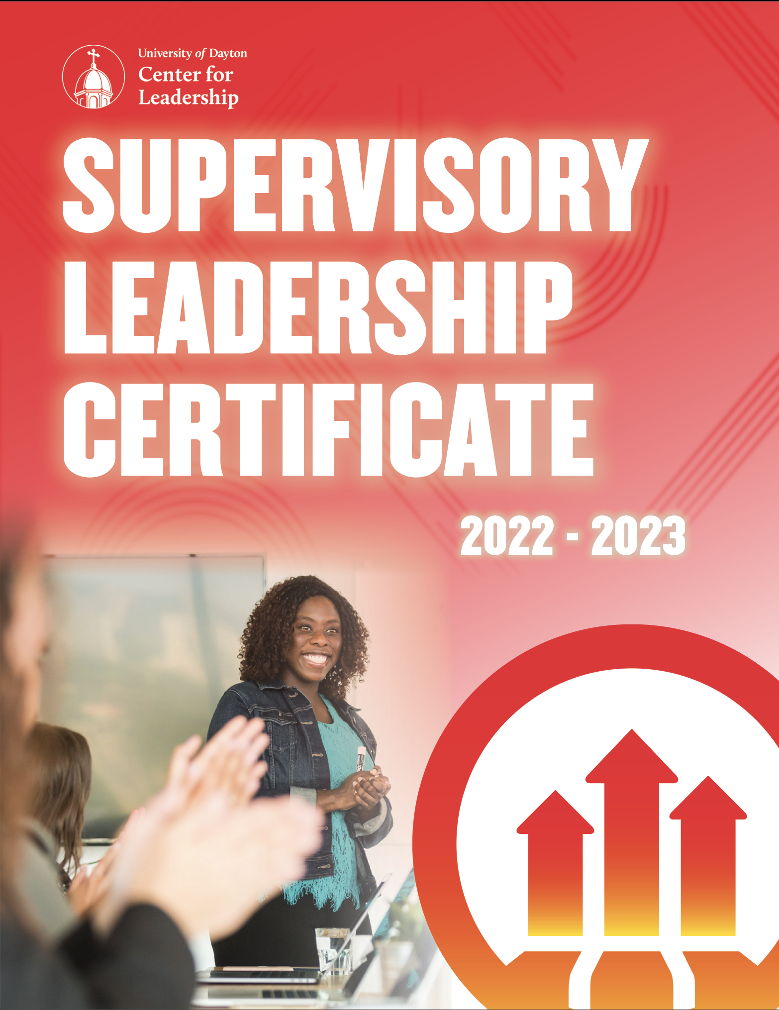

JANUARY 2022
1/20 Orientation: Understanding Leadership & Team Development
2/2 Mentor Training
2/17 Going from Peer to Supervisor
2/18 360 Assessment Feedback Session
3/8 Time Management & Personal Productivity
3/29 Communication Skills for Leaders
4/12 Navigating Difficult Conversations
4/27 Coaching & Evaluating Performance
5/11 Effective Decision Making
5/26 Leading Change at the First Level
6/16 Leadership is Everyone’s Business

MAY 2022
5/24 Orientation: Understanding Leadership & Team Development
6/7 Mentor Training
6/22 Going from Peer to Supervisor
6/29 360 Assessment Feedback Session
7/15 Time Management & Personal Productivity
7/27 Navigating Difficult Conversations
8/9 Communication Skills for Leaders
8/24 Coaching & Evaluating Performance
9/8 Effective Decision Making
9/28 Leading Change at the First Level
10/13 Leadership is Everyone’s Business

OCTOBER 2022
10/4 Orientation: Understanding Leadership & Team Development
10/20 Mentor Training
11/8 Going from Peer to Supervisor
11/18 360 Assessment Feedback Session
12/1 Time Management & Personal Productivity
1/12/23 Communication Skills for Leaders
1/24/23 Navigating Difficult Conversations
2/8/23 Coaching & Evaluating Performance
2/22/23 Effective Decision Making
3/8/23 Leading Change at the First Level

3/23/23 Leadership is Everyone's Business

MARCH 2022
3/18 Orientation: Understanding Leadership & Team Development
3/30 Mentor Training
4/21 Going from Peer to Supervisor
4/29 360 Assessment Feedback Session
5/18 Time Management & Personal Productivity
6/2 Communication Skills for Leaders
6/21 Navigating Difficult Conversations
7/13 Coaching & Evaluating Performance
8/2 Effective Decision Making
8/11 Leading Change at the First Level
8/25 Leadership is Everyone’s Business

AUGUST 2022
8/4 Orientation: Understanding Leadership & Team Development
8/17 Mentor Training
9/15 Going from Peer to Supervisor
9/16 360 Assessment Feedback Session
9/22 Time Management & Personal Productivity
10/5 Communication Skills for Leaders
10/26 Navigating Difficult Conversations
11/10 Coaching & Evaluating Performance
12/13 Effective Decision Making
1/11/23 Leading Change at the First Level

1/26/23 Leadership is Everyone's Business

Every leader has a unique path. Let us be your guide.
Identify the competency or skill you are looking to develop from the list below and find the programs that will address that skill. Program dates and descriptions are listed in detail throughout this document.

Factor I: Thought

Manages Complexity
- Effective Decision Making

Decision Quality
- Effective Decision Making

Factor II: Results

Resourcefulness
- Going From Peer to Supervisor

Directs Work
- Coaching & Evaluating Performance
- Going From Peer to Supervisor

Plans & Aligns
- Effective Decision Making
- Time Management & Personal Productivity

Optimizes Work Processes
- Time Management & Personal Productivity

Drives Results
- 360 Assessment Feedback Session
- Effective Decision Making

Factor III: People

Collaborates
- 360 Assessment Feedback Session
- Coaching & Evaluating Performance
- Effective Decision Making
- Leadership is Everyone’s Business

Manages Conflict
- Navigating Difficult Conversations

Interpersonal Savvy
- Communication Skills for Leaders
- Mentor Training

Develops Talent
- Coaching & Evaluating Performance

Builds Effective Teams
- Orientation: Understanding Leadership & Team Development

Communicates Effectively
- Coaching & Evaluating Performance
- Communication Skills for Leaders
- Navigating Difficult Conversations
- Orientation: Understanding Leadership & Team Development

Builds Networks
- Mentor Training

Drives Engagement
- Leadership is Everyone’s Business
- Mentor Training
- Orientation: Understanding Leadership & Team Development

Persuades
- Communication Skills for Leaders

Drives Vision & Purpose
- Leadership is Everyone’s Business

Factor IV: Self

Courage
- Leadership is Everyone’s Business
- Leading Change at the First Level

Instills Trust
- Leadership is Everyone’s Business

Demonstrates Self-Awareness
- 360 Assessment Feedback Session
- Mentor Training
- Orientation: Understanding Leadership & Team Development

Self-Development
- 360 Assessment Feedback Session
- Going From Peer to Supervisor
- Mentor Training
- Navigating Difficult Conversations
- Orientation: Understanding Leadership & Team Development
- Time Management & Personal Productivity

Manages Ambiguity
- Leading Change at the First level
- Time Management & Personal Productivity

Nimble Learning
- 360 Assessment Feedback Session
- Leading Change at the First Level

Being Resilient
- Leading Change at the First Level

Situational Adaptability
- Leading Change at the First Level
- Navigating Difficult Conversations

Orientation: Understanding Leadership & Team Development

JAN. 20, 2022 | MARCH 18, 2022 | MAY 24, 2022 | AUG. 4, 2022 | OCT. 4, 2022 9:00 A.M.–4:00 P.M.
Effective leadership starts with you. In this interactive program, you will utilize a DiSC self-assessment that will help you understand your personal workplace priorities, motivators, and stress triggers. With personalized insights and actionable strategies, you will learn how to adapt to the style of others, ultimately improving engagement and collaboration. Learn about other style types, understanding the differences and similarities among styles, and identify strategies to build more high-performance teams to deliver on the mission and vision of your organization.

This program will help leaders:
- Identify personal strengths, opportunities, and impacts of workplace behaviors.
- Develop a plan to work with others whose styles are different from your own.
- Learn how to strengthen team dynamics in order to accelerate high performance.
Competencies Addressed: Builds Effective Teams, Communicates Effectively, Demonstrates Self-Awareness, Drives Engagement, Self-Development

Mentor Training
FEB. 2, 2022 | MARCH 30, 2022 | JUNE 7, 2022 | AUG. 17, 2022 | OCT. 20, 2022 9:00 A.M.–12:00 P.M.
This session offers critical training for both first-level leaders and mentors to help start the mentoring relationship on the right track. First-level leaders and their mentors attend this session together and leave with a better understanding of what formal mentoring truly entails. Using a unique process that identifies and leverages preferred styles of mentoring, we help you clearly define your unique mentoring relationship. First-level leaders and mentors collaboratively outline the expectations and guidelines for how to best work together during the next six months to foster the first-level leader’s development.

This program will help leaders:
- Recognize the difference between formal and informal mentoring.
- Assess the preferred mentoring styles and the styles of their partner.
- Understand and practice four different styles of mentoring and there uses.
Competencies Addressed: Builds Networks, Demonstrates Self-Awareness, Drives Engagement, Interpersonal Savvy, Self- Development

Going From Peer to Supervisor
FEB. 17, 2022 | APRIL 21, 2022 | JUNE 22, 2022 | SEP. 15, 2022 | NOV. 8, 2022 9:00 A.M.–4:00 P.M.
This interactive program guides you through the transformation from individual contributor to leader. Through small group exercises, group discussions, and skill practice, you explore the strategies, behaviors, and critical interactions that help assure an easier transition through this essential rite of passage for those who want to advance into management.

This program will help leaders:
- Understand the issues and challenges of transitioning into a supervisory role.
- Address how to handle some of the common challenges presented to new supervisors.
- Become equipped to manage self and team through transition.
Competencies Addressed: Directs Work, Resourcefulness, Self-Development

360 Assessment Feedback Session
FEB. 18, 2022 | APRIL 29, 2022 | JUNE 29, 2022 | SEP. 16, 2022 | NOV. 18, 2022 9:00 A.M.–12:00 P.M.
All leaders should take advantage of the "gift of feedback." This is especially true when the feedback is formalized through a 360 assessment. Participants of this session will receive feedback that has been provided by their manager, peers, direct reports, and others. The feedback is based on the quality of behaviors as perceived by the raters. In this session, a certified coach will walk participants through their feedback that will lay the foundation for the creation of a developmental plan.

This program will help leaders:
- Identify your strengths and improvement areas based on the perception of your raters.
- Compare your self-perception within the critical competencies as compared to the perception of the other raters.
- Lay a foundation based on the feedback to start the process of a developmental plan.
Competencies Addressed: Demonstrates Self Awareness, Self-Development, Nimble Learning, Drives Results, Collaborates

Time Management & Personal Productivity
MARCH 8, 2022 | MAY 18, 2022 | JULY 15, 2022 | SEP. 22, 2022 | DEC. 1, 2022 9:00 A.M.–4:00 P.M.
As a leader advancing in an organization, one of the things you quickly realize is the way you manage your time is in direct correlation with how successfully you, along with your team, will perform. Learning how to invest your time wisely is a critical skill in the workplace, but it is one which we do not spend a great deal of time trying to learn or master. This program will answer those questions and give you tactics that can be applied when you return to your organization. You will be exposed to some valuable tools that help create an immediate impact in time management and personal productivity.

This program will help leaders:
- Plan and prioritize using proven scheduling techniques.
- Navigate common productivity obstacles.
- Embrace essential actions to increase energy.
Competencies Addressed: Manages Ambiguity, Optimizes Work Processes, Plans & Aligns, Self-Development

Communication Skills for Leaders
MARCH 29, 2022 | JUNE 2, 2022 | AUG. 9, 2022 | OCT. 5, 2022 | JAN. 12, 2023 9:00 A.M.–4:00 P.M.
As professionals today, our writing and thinking skills are showcased daily through e-mail and other forms of messaging, including both in-person and virtual meetings. Employees at all levels need to be able to communicate ideas effectively to customers, vendors, co-workers, and management – and build meaningful relationships in the process. This session will provide hands-on practice with key strategies for expressing yourself clearly and optimizing your professional credibility as you move into supervisory and/or leadership roles.

This program will help leaders:
- Showcasing your professional “brand” through writing, including crafting routine emails for optimal readability and goodwill.
- Motivating audience action through behavioral-style messages.
- Building your team, whether in person or remotely, through effective meetings and other forms of professional engagement.
Competencies Addressed: Communicates Effectively, Interpersonal Savvy, Persuades

Navigating Difficult Conversations
APRIL 12, 2022 | JUNE 21, 2022 | JULY 27, 2022 | OCT. 26, 2022 | JAN. 24, 2023 9:00 A.M.–4:00 P.M.

Leaders often delay or avoid initiating difficult conversations especially when they anticipate an emotional reaction. However, avoiding these conversations can be costly to your organization and your career. When a conversation is approached with a positive and learning intent, relationships are strengthened, morale and trust improve, and productivity is higher.

This program will help leaders:
- Recognize your use of emotional intelligence and empathy in creating a comfortable and effective conversation.
- Create and practice an opening statement that will engage others in the conversation.
- Identify and practice a five-step process that will help you prepare, initiate, and conduct a conversation that you view as difficult.
Competencies Addressed: Communicates Effectively, Manages Conflict, Self-Development, Situational Adaptability

Coaching & Evaluating Performance
APRIL 27, 2022 | JULY 13, 2022 | AUG. 24 2022 | NOV. 10, 2022 | FEB. 8, 2023 9:00 A.M.–4:00 P.M.
This program is designed to enhance a leader’s management skills and prepare him or her for the changing demands of today’s workforce. A manager’s ability to provide regular coaching is critical to ensuring that individuals, and the team, reach their peak performance. This session introduces you to concepts and skills that can be used to provide coaching to either develop the skills of staff members or to correct performance issues. You also explore the performance review process and how to conduct performance appraisals.

This program will help leaders:
- Describe the key elements of an effective performance evaluation process.
- Use an analysis tool to identify the root cause of the performance issue.
- Demonstrate the first step of the coaching conversation.
Competencies Addressed: Collaborates, Communicates Effectively, Develops Talent, Directs Work

Effective Decision Making
MAY 11, 2022 | AUG. 2, 2022 | SEP. 8, 2022 | DEC. 13, 2022 | FEB. 22, 2023 9:00 A.M.–4:00 P.M.
Q - What shapes an individual’s career and life, as well as defines them as a leader? A - Their decisions.

Gallup has spent five decades studying leaders at all levels of an organization and found two elements that consistently characterize effective leaders. One of those elements is making effective decisions. Just like an individual’s success is shaped by their decisions, so is the success of an organization. Whether it's decisions about how to integrate change, strategic direction, new technology, or how to best develop and market their products/services - every opportunity seized or missed is the result of a decision that someone makes. What does it take to make a great decision? Leaders are constantly making and implementing decisions, but few examine the process or know how to assess the quality of their decisions. In today's environment, the impact of a poorly made decision can be costly. On the other hand, a great decision can produce results that will move an organization forward. This program utilizes group exercises and real-world case studies to provide participants with a process and the tools for making effective decisions.

This program will help leaders:
- Learn four distinct styles of decision making and when to apply them.
- Learn how to apply some “quality control” to the decisions you make.
- Understand various tools that aid the decision-making process.
Competencies Addressed: Collaborates, Decision Quality, Drives Results, Manages Complexity, Plans & Aligns

Leading Change at the First Level
MAY 26, 2022 | AUG. 11, 2022 | SEP. 28, 2022 | JAN. 11, 2023 | MARCH 8, 2023 9:00 A.M.–4:00 P.M.

In addition to leading day-to-day operations, managers are also responsible for adapting to change and for leading others to adapt to change. This program will deepen your understanding of what the brain needs to adapt effectively to change and will increase your skills in three areas: personally adjusting to change, leading others through change, and building/increasing change adaptation competence.

This program will help leaders:
- Understand the human brain’s natural reactions to significant change.
- Deepen awareness of effective change leadership tactics.
- Recognize the primary keys to being consciously change resilient.
Competencies Addressed: Being Resilient, Courage, Manages Ambiguity, Nimble Learning, Situational Adaptability

Leadership Is Everyone’s Business
JUNE 16, 2022 | AUG. 25, 2022 | OCT. 13, 2022 | JAN. 26, 2023 | MARCH 23, 2023 9:00 A.M.–4:00 P.M.
Todays—and tomorrows—most successful organizations are creatively adapting to unceasing change and uncertainty by encouraging leadership at every level of the organization. The new competitive requirements— quality, innovation, customer responsiveness, and flexibility—demand an organization filled with people taking the lead in improving processes, collaborating on products, and responding appropriately to ever-changing markets. Managers, while struggling to get better results with fewer people and resources, are realizing that full participation is not “good”; it is critical. In this program, you will discover how you have shown leadership in the past to meet business and personal challenges, allowing you to gain the confidence and skill to increase your use of The Five Practices of Exemplary Leadership on the job.

This program will help leaders:
- Recognize how leadership is key to their ability to succeed in challenging situations.
- Identify their leadership strengths and areas for improvement.
- Understand and implement the Five Practices of Exemplary Leadership.
Competencies Addressed: Collaborates, Courage, Drives Engagement, Drives Vision & Purpose, Instills Trust

