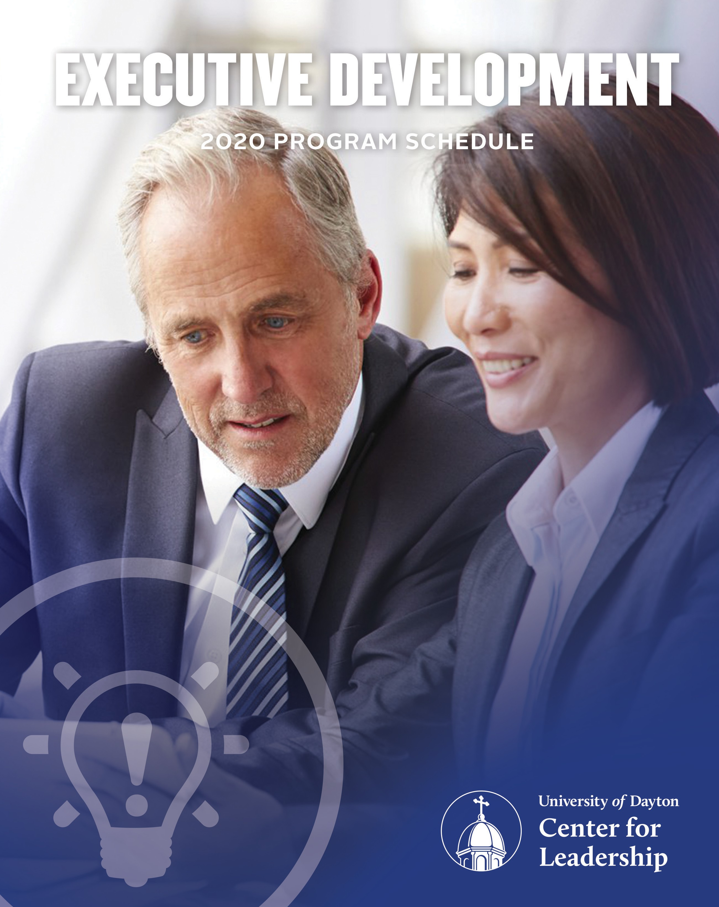

Date | Program
02/12 | Lead, Follow, or Get Out of the Way:  Accountability for Superior Results | Linda Galindo
03/24 | Crucial Conversations for Leaders:  Tools for Talking When Stakes are High (AM)  Influencer: The New Science of Leading Change (PM) | Joseph Grenny
04/16 | Innovation is Everybody’s Business: How to Ignite, Scale,  and Sustain for a Competitive Advantage | Tamara Ghandour
05/14 | Intentional Purpose: Building Your Brand as a Leader | Dorie Clark
09/09 | The Power of Healthy Tension:  Overcome Chronic Issues and Conflicting Values | Tim Arnold
10/06 | The Surprising Truth About Motivation (AM)  The Scientific Secrets of Perfect Timing:  Lessons for Leaders (PM) | Daniel Pink
10/28 | How Women Rise: Helping Women Reach Their Full Potential | Sally Helgesen
11/17 | The Reality About Employee Engagement and Your Bottom Line | Richard Hadden
CALENDAR

FACTORS

Every leader has a unique path. Let us be your guide.
Identify the competency or skill you are looking to develop from the list below and find the programs that will address that skill. Program dates and descriptions are listed in detail throughout this document.

Factor I: Thought
Manages Complexity
September 9, 2020: The Power of Healthy Tension: Overcome Issues and Conflicting Values by Tim Arnold.
Decision Quality
October 6, 2020 (PM): The Scientific Secrets of Perfect Timing: Lessons for Leaders by Daniel Pink.
Cultivates Innovation
April 16, 2020: Innovation is Everybody's Business: How to Ignite, Scale, and Sustain for a Competitive Advantage by Tamara Ghandour.
Factor II: Results
Action Oriented
- March 24, 2020 (PM): Influencer: The New Science of Leading Change by Joseph Grenny.
Plans and Aligns
- October 6, 2020 (PM): The Scientific Secrets of Perfect Timing: Lessons for Leaders by Daniel Pink.
Optimizes Work Processes
- October 6, 2020 (PM): The Scientific Secrets of Perfect Timing: Lessons for Leaders by Daniel Pink.
Ensures Accountability
- February 12, 2020: Lead, Follow, or Get Out Of The Way: Accountability for Superior Results by Linda Galindo.
- March 24, 2020 (PM): Influencer: The New Science of Leading Change by Joseph Grenny.
Drives Results
- February 12, 2020: Lead, Follow, or Get Out Of The Way: Accountability for Superior Results by Linda Galindo.
- March 24, 2020 (AM): Crucial Conversations for Leaders: Tools for Talking When Stakes Are High by Joseph Grenny
- March 24, 2020 (PM): Influencer: The New Science of Leading Change by Joseph Grenny.
- April 16, 2020: Innovation is Everybody's Business: How to Ignite, Scale, and Sustain for a Competitive Advantage by Tamara Ghandour.
- October 6, 2020 (AM): The Surprising Truth About Motivation by Daniel Pink.
- October 6, 2020 (PM): The Scientific Secrets of Perfect Timing: Lessons for Leaders by Daniel Pink.
- November 17, 2020: The Reality About Employee Engagement and Your Bottom Line by Richard Hadden.
Factor III: People
Manages Conflict
- March 24, 2020 (AM): Crucial Conversations for Leaders: Tools for Talking When Stakes Are High by Joseph Grenny.
Builds Networks
- May 14, 2020: Intentional Purpose: Building Your Brand As A Leader by Dorie Clark.
Attracts Top Talent
- November 17, 2020: The Reality About Employee Engagement and Your Bottom Line by Richard Hadden.
Develops Talent
- October 6, 2020 (AM): The Surprising Truth About Motivation by Daniel Pink.
- October 28, 2020: How Women Rise: Helping Women Reach Their Full Potential by Sally Helgesen.
- November 17, 2020: The Reality About Employee Engagement and Your Bottom Line by Richard Hadden.
Values Differences
- September 9, 2020: The Power of Healthy Tension: Overcome Issues and Conflicting Values by Tim Arnold.
- October 28, 2020: How Women Rise: Helping Women Reach Their Full Potential by Sally Helgesen.
Builds Effective Teams
- February 12, 2020: Lead, Follow, or Get Out Of The Way: Accountability for Superior Results by Linda Galindo.
- April 16, 2020: Innovation is Everybody's Business: How to Ignite, Scale, and Sustain for a Competitive Advantage by Tamara Ghandour.
- September 9, 2020: The Power of Healthy Tension: Overcome Issues and Conflicting Values by Tim Arnold.
- October 6, 2020 (AM): The Surprising Truth About Motivation by Daniel Pink.
- November 17, 2020: The Reality About Employee Engagement and Your Bottom Line by Richard Hadden.
Communicates Effectively
- March 24, 2020 (AM): Crucial Conversations for Leaders: Tools for Talking When Stakes Are High by Joseph Grenny.
- May 14, 2020: Intentional Purpose: Building Your Brand As A Leader by Dorie Clark.
Drives Engagement
- February 12, 2020: Lead, Follow, or Get Out Of The Way: Accountability for Superior Results by Linda Galindo.
- March 24, 2020 (PM): Influencer: The New Science of Leading Change by Joseph Grenny.
- April 16, 2020: Innovation is Everybody's Business: How to Ignite, Scale, and Sustain for a Competitive Advantage by Tamara Ghandour.
- October 6, 2020 (AM): The Surprising Truth About Motivation by Daniel Pink.
- October 6, 2020 (PM): The Scientific Secrets of Perfect Timing: Lessons for Leaders by Daniel Pink.
- October 28, 2020: How Women Rise: Helping Women Reach Their Full Potential by Sally Helgesen.
- November 17, 2020: The Reality About Employee Engagement and Your Bottom Line by Richard Hadden.
Organizational Savvy
- May 14, 2020: Intentional Purpose: Building Your Brand As A Leader by Dorie Clark.
- October 28, 2020: How Women Rise: Helping Women Reach Their Full Potential by Sally Helgesen.
Drives Vision and Purpose
- March 24, 2020 (PM): Influencer: The New Science of Leading Change by Joseph Grenny.
- October 6, 2020 (AM): The Surprising Truth About Motivation by Daniel Pink.

Factor IV: Self
Courage
- February 12, 2020: Lead, Follow, or Get Out Of The Way: Accountability for Superior Results by Linda Galindo.
- March 24, 2020 (AM): Crucial Conversations for Leaders: Tools for Talking When Stakes Are High by Joseph Grenny
- September 9, 2020: The Power of Healthy Tension: Overcome Issues and Conflicting Values by Tim Arnold.
Instills Trust
- March 24, 2020 (AM): Crucial Conversations for Leaders: Tools for Talking When Stakes Are High by Joseph Grenny
Demonstrates Self-Awareness
- May 14, 2020: Intentional Purpose: Building Your Brand As A Leader by Dorie Clark.
Self-Development
- May 14, 2020: Intentional Purpose: Building Your Brand As A Leader by Dorie Clark.
- October 28, 2020: How Women Rise: Helping Women Reach Their Full Potential by Sally Helgesen.
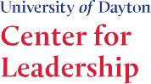
Nimble Learning
- April 16, 2020: Innovation is Everybody's Business: How to Ignite, Scale, and Sustain for a Competitive Advantage by Tamara Ghandour.
Situational Adaptability
- September 9, 2020: The Power of Healthy Tension: Overcome Issues and Conflicting Values by Tim Arnold.

LINDA GALINDO
LEAD, FOLLOW, OR GET OUT OF THE WAY: ACCOUNTABILITY FOR
SUPERIOR RESULTS

FEBRUARY 12, 2020 | 8:30 A.M. – 4:30 P.M.

In today’s workplace, the concept of accountability has taken center stage as a vital business concern. Yet it is all too often confused with punishment, fault-finding, blame, and guilt. If employees take ownership for the success or failure of tasks, projects or initiatives, then an environment of trust, alignment, communication, and accountability can be created.

Personal accountability results in less time spent managing, and more time spent coaching, mentoring, and leading. Employees who demonstrate responsibility, self-empowerment, and accountability are an organization’s competitive advantage and the one’s you want to develop as your organization’s future leaders.

Linda Galindo will show you how to instill accountability in the workplace starting with yourself. Participants in this program will benefit from completing the Mindset of Accountability Assessment which will help to diagnose your starting point for accountability and understand the reasons for your frustrations. You will also learn how to create an environment of ownership for results before the fact that creates clear agreements, execution on plans, and success for your organization, your team, and yourself.

This program will help leaders:
- Apply a new constructive definition of what accountability, responsibility, and empowerment mean in today’s workplace.
- Evaluate your own accountability mindset and what it means to you, your performance, and your job satisfaction.
- Bring new ideas to team accountability in a way that minimize conflict and encourage improved results.
Competencies Addressed: Builds Effective Teams, Courage, Drives Engagement, Drives Results, Ensures Accountability
LINDA GALINDO
Linda Galindo is an international author, educator, speaker, and consultant who is an expert in the field of personal and organizational accountability and high-performance executive team building. Linda speaks nationally on the topics of leadership accountability and creating the culture change to bring about an accountable organization. Over the
past 20 years, she has worked with CEOs, surgeons, elected officials, and organizations including The Naval Reactors Facility, The Sundance Institute, LinkedIn, the Children’s Hospital of Philadelphia, Park City Municipal Corporation, and Genetech. Linda authored the 85% Solution, How Personal Accountability Guarantees Success. No Nonsense. No Excuses, Where Winners Live (coauthor), and Way to Grow!

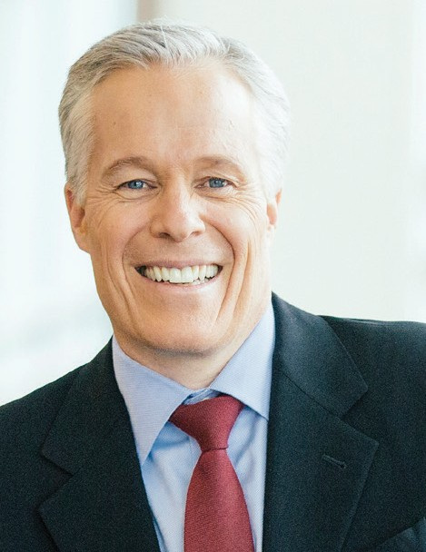

JOSEPH GRENNY
CRUCIAL CONVERSATIONS FOR LEADERS: TOOLS FOR TALKING WHEN STAKES ARE HIGH

MARCH 24, 2020 | 9:00 A.M. – 12:00 P.M.

Problem-plagued organizations often share the same root cause: perplexed employees who aren’t quite sure how to bring up touchy, controversial, and complex issues and resolve them. And when three key forces show up—strong emotions, differing opinions, or high stakes—key organizational results suffer. The right skills—can help organizations of any size reach dialogue and achieve impressive results.

After more than thirty years of research in two dozen industries involving more than 25,000 individuals, Joseph Grenny has observed leaders struggle with poor performance, stalled change initiatives, low productivity, strained relationships, and general lack of results. His observations confirm that leaders who avoid talking honestly with the right people about the right issues can expect poor results.

The authors of Crucial Conversations found that most of the time, the most influential people were indistinguishable from their peers. The breakthrough discovery came when the stakes grew high, emotions were strong, and opinions differed. In these crucial moments, top-rated leaders routinely employed skills that turned diverse thought into synergy and synergy into results by mastering crucial conversations.

Joseph will guide you through the steps to mastering crucial conversations and harnessing the power of turning every employee interaction into an experience that achieves synergy, alignment, and agreement. You will walk away from this program with a new set of high leverage tools to effectively achieve breakthrough results.

This program will help leaders:
- Develop the skills needed to step up to controversial and heated issues.
- Professionally discuss issues in a way that makes it safe for everyone to speak.
- Create an environment where people share their best ideas, make wise decisions, and then act with conviction.
Competencies Addressed: Communicates Effectively, Courage, Drives Results, Instills Trust, Manages Conflict
JOSEPH GRENNY
Joseph Grenny is coauthor of four New York Times bestsellers and creator of four award winning training programs of the same titles—Crucial Conversations, Crucial
Accountability, Influencer, and Change Anything. Over the past twenty-five years, Joseph has taught and advised thousands of leaders on every major continent from the boardrooms of Fortune 500 companies to the community of Nairobi, Kenya. He has been cited in every major newspaper including the New York Times, Los Angeles Times, Washington Post, and the Wall Street Journal. Joseph has appeared on hundreds of radio and television programs including the Today Show, ABC News, CNN, Bloomberg, and CNBC, and contributes regularly at Forbes.com.

JOSEPH GRENNY
INFLUENCER: THE NEW SCIENCE OF LEADING CHANGE

MARCH 24, 2020 | 1:00 P.M. – 4:00 P.M.

We know the best leaders comprehend the importance of getting individuals to work together to accomplish goals; however, this is easier said than done. We do our best each day to motivate employees to demonstrate more concern for what we feel is important. We even provide incentives for our teams to do great work. And still, the attempts we make to exert our influence often times still fall short in us reaching our objectives.

It is safe to say that creating sustainable change is a constant struggle for individuals and organizations. We often lack the skills to influence the behaviors behind issues like: failed initiatives, short-lived change efforts, unproductive corporate culture, and entrenched bad habits. The key to overcoming these frustrations is mastering the skill of being an intentional influencer of change.

We all need to be influencers. Hardly a day passes that we don’t try to influence ourselves or others to do something new and different. Whether you’re looking to improve your relationships with direct reports or inspiring employees to demonstrate more concern for profitability, you are continually working on ways to exert influence.

In spite of the fact that we’re routinely trying to alter behavior, few of us can articulate an effective strategy to create this behavior change. It’s time this changed! By drawing from the skills of many of the world’s best change agents and combining them with five decades of social-science research, Joseph Grenny will help provide you with a powerful and portable model for behavior change.

This program will help leaders:
- Successfully lead change initiatives.
- Diagnose the real causes behind the problems and create real solutions.
- Influence behavior across the organization with or without formal authority.
Competencies Addressed: Action Oriented, Drives Engagement, Drives Results, Ensures Accountability, Instills Vision and Purpose
JOSEPH GRENNY
Joseph Grenny is coauthor of four New York Times bestsellers and creator of four award winning training programs of the same titles—Crucial Conversations, Crucial
Accountability, Influencer, and Change Anything. Over the past twenty-five years, Joseph has taught and advised thousands of leaders on every major continent from the boardrooms of Fortune 500 companies to the community of Nairobi, Kenya. He has been cited in every major newspaper including the New York Times, Los Angeles Times, Washington Post, and the Wall Street Journal. Joseph has appeared on hundreds of radio and television programs including the Today Show, ABC News, CNN, Bloomberg, and CNBC, and contributes regularly at Forbes.com.

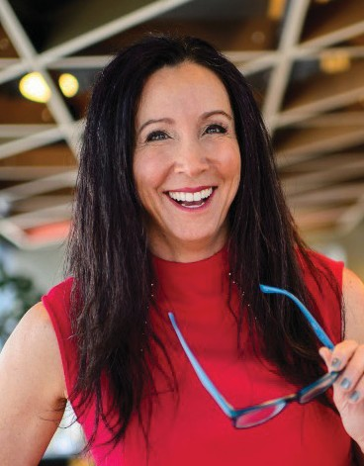

TAMARA GHANDOUR
INNOVATION IS EVERYBODY’S BUSINESS: HOW TO
IGNITE, SCALE, AND SUSTAIN FOR A
COMPETITIVE ADVANTAGE

APRIL 16, 2020 | 8:30 A.M. – 4:30 P.M.

As a leader, you know that in today’s climate, organizations can’t afford to maintain a business-as-usual mentality. As the pressure intensifies, organizations must focus on innovation if they want to outmaneuver the changing marketplace and outperform the competition. But, the key to a thriving culture of innovation isn’t in certain people, processes, or segments of the organization. The key to lasting success is to making innovation everybody’s business. That doesn’t happen through implementing the latest process or buying a new system. Innovation happens through people as people create the culture shift.

In this highly interactive and real-world based program, Tamara Ghandour is going to share how to avoid the “traps of certainty” and easily adapt the Innovation Quotient Edge program that helps leaders and teams ignite, scale, and sustain innovation through their greatest asset - themselves and the teams they lead. The Innovation Quotient Edge (IQE) program is the only proprietary tool of its kind that tells you how you naturally innovate and then gives you the tools to weave innovation into the DNA of your teams. You’ll join the thousands of people across the globe that have taken the IQE assessment and unlocked their Everyday Innovator™ style for higher performance both individually and as a team. With the correlating mindset and exercises that Tamara will walk you through, you’ll be able to easily implement innovation every day, avoid initiative fatigue, and transform your teams from a group of A-players to a high- performance team.

This program will help leaders:
- Bring to life the real definition of innovation to ignite, scale, and sustain daily innovation.
- Deep dive into their Everyday InnovatorTM style to become stronger leaders with more innovative voices.
- Create a lasting culture of innovation that impacts the bottom line.
Competencies Addressed: Builds Effective Teams, Cultivates Innovation, Drives Engagement, Drives Results, Nimble Learning
TAMARA GHANDOUR
Tamara Ghandour is the founder of LaunchStreet. She has helped teams across the globe compete, and win, by tapping the power of innovation. With more than twenty-five years of business experience, Tamara knows what it takes to drive growth and innovation daily in an ever-changing marketplace. Her Innovation Quotient Edge (IQE) Assessment is the only tool able to measure people’s natural innovation strengths and deliver insights and tools for performing at their peak, therefore, bringing more innovative ideas to the table and building high-performance teams. When companies like Disney, General Mills, Hilton, and Red Robin want to up their innovation quotient, they call Tamara. Her top-rated business innovation podcast, Inside LaunchStreet, is listened to by thousands of innovators across the globe.

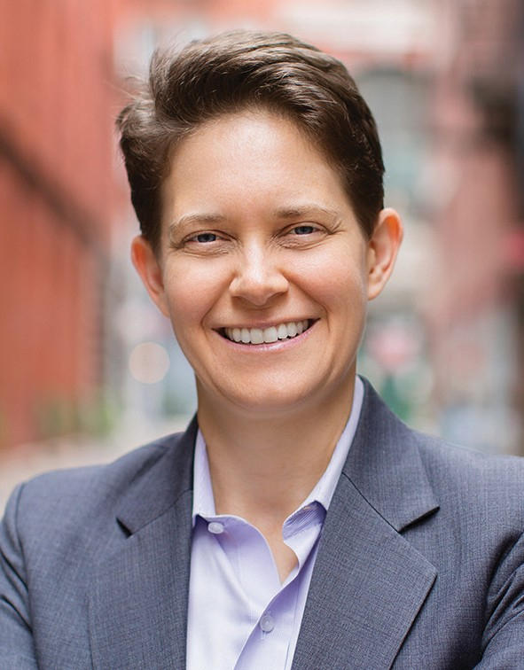

DORIE CLARK
INTENTIONAL PURPOSE: BUILDING YOUR BRAND AS A LEADER

MAY 14, 2020 | 8:30 A.M. – 4:30 P.M.

Being recognized as a compelling leader can dramatically accelerate your professional success. Are you where you want to be professionally? As leaders, whether you want to advance faster within your organization, move into a new position, get noticed for how well you are performing, or maybe explore other opportunities all together, one thing is clear: to succeed, you have to build a strong and credible brand that leverages your unique passions and talents. In building your brand, a leader really has a couple of choices: you can let those around you determine and manage how you are seen or you can take a proactive approach and lead the way.

While taking control of your leadership brand can mean different things to different people, an intentional, purposeful, and strategic approach is what is needed in order to achieve your aspirations in today’s competitive environment. The days of putting your head down, working hard, and hoping the next opportunity will come may help, but there is more to you achieving what you want and that is driven by how you are viewed and perceived by key stakeholders you have the power to influence.

In this highly engaging and interactive program, Dorie Clark will first provide you with proven techniques that will help you to determine how you are currently viewed. Next, she will guide you through a step-by-step approach to building or reinventing your brand as a leader in order to increase the likelihood of you getting what you want out of work and life. But, this is not enough…being able to clearly communicate and live your brand effectively will drive you to what you want to achieve.

This program will help leaders:
- Discover and understand how their brand is being perceived.
- Develop a roadmap to establishing and cultivating the brand they want to leverage.
- Communicate and live their brand effectively to others.
Competencies Addressed: Builds Networks, Communicates Effectively, Demonstrates Self- Awareness, Organizational Savvy, Self-Development
DORIE CLARK
Dorie Clark is a marketing strategy consultant, professional speaker, and frequent contributor to the Harvard Business Review. Recognized as a “branding expert” by the Associated Press, Fortune, and Inc. magazine, she is the author of Entrepreneurial You, Reinventing You, and Stand Out, which was named the #1 Leadership Book of 2015 by Inc. magazine. A former presidential campaign spokeswoman, the New York Times described her as an “expert at self-reinvention and helping others make changes in their lives.” Besides being a professor at Duke University’s Fuqua School of Business, she consults and speaks for clients including Google, Microsoft, and the World Bank.

TIM ARNOLD
THE POWER OF HEALTHY TENSION: OVERCOME
CHRONIC ISSUES AND CONFLICTING VALUES

SEPTEMBER 9, 2020 | 8:30 A.M. – 4:30 P.M.

Often leaders and teams have a clear vision, but fail to live it out. They feel stuck because of conflicting values, division within the team, and a resistance to change. As humans, we tend to naturally see things from a right or wrong, or good or bad perspective, and take an either/or approach to these situations.

Leaders and teams are often in a tug-of-war, facing competing demands such as planning vs. action, structure vs. flexibility, change vs. stability, and work vs. home. But this “either/ or” thinking is a dangerous trap! In order to excel – both at work and home – leaders need to realize that many of life’s challenges are tensions to be tackled or managed head on. Leaders are ineffective when they can’t navigate conflicting points of view or tension.

In this program, Tim Arnold will help you understand the chronic issues that hold back leadership and teams, so you can thrive! The secret to addressing this issue is realizing and embracing that a certain kind of tension – healthy tension - can be incredibly positive. The Power of Healthy Tension will provide a practical framework that allows leaders to tap into the power of “both/and” thinking. By doing this, you gain a massive competitive advantage, and move from surviving to thriving.

This program will help leaders:
- Gain the ability to work effectively with people who have different opinions and perspectives than their own.
- Understand the difference between a problem to solve and a tension to manage, and the skills required to communicate conflicting points of view.
- Learn a thoughtful, deliberate decision-making approach when dealing with complex issues.
Competencies Addressed: Builds Effective Teams, Courage, Manages Complexity, Situational Adaptability, Values Differences

TIM ARNOLD
Tim Arnold is the author of the bestselling book, The Power of Healthy Tension: Overcoming Chronic Issues and Conflicting Values. Tim provides his audiences with powerful tools that help them understand and breakthrough the chronic issues they face in both their professional and personal lives. He provides his clients with a real-world perspective through his experience launching successful for-profit and not-for-profit businesses, overseeing community outreach and healthcare programs, and managing international development partnerships in four continents. Tim has spent over two decades helping organizations unite teams, spark change, and get unstuck, with clients that include The United Nations, Citibank, KPMG, Toyota, and Siemens.

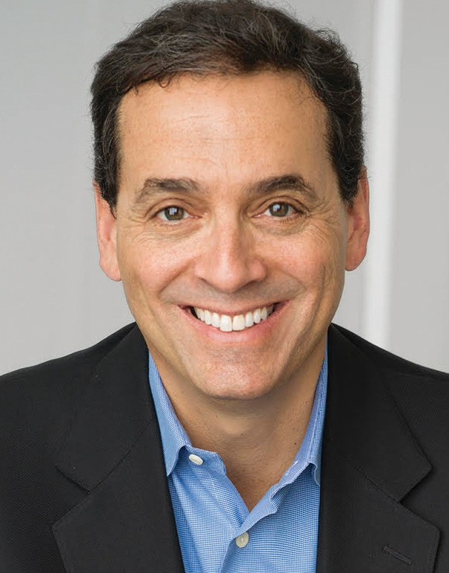

DANIEL PINK
THE SURPRISING TRUTH ABOUT MOTIVATION

OCTOBER 6, 2020 | 8:30 A.M. – 12:00 P.M.

What motivates people to do their best work? The question is central to leadership, strategy, and innovation. And this compelling, evidence-based program provides the answer.

Daniel Pink, author of the international bestseller Drive, will show that the secret to high performance and satisfaction—at work and at home—is the deeply human need to direct our own lives, to learn, and create new things, and to do better by ourselves and our world.

Tapping over 50 years of research in behavioral science, Dan will explain why many traditional rewards fall short of their promise and sometimes even backfire. He will reveal the mismatch between what science knows and what organizations do – and show how to close the gap between knowing and doing.

He will explain a revised motivational operating system that when used properly can have a positive impact on our personal and professional lives. This system, which has been embraced by smart leaders and organizations around the world, promotes enduring motivation through three critical elements—autonomy, mastery, and purpose.

This program will help leaders:
- Understand the reality of what really motivates people to do their best work.
- Reinvent performance reviews to boost employee engagement and productivity.
- Enlist the two types of purpose that science shows can dramatically boost performance.
Competencies Addressed: Builds Effective Teams, Drives Engagement, Drives Results, Developing Talent, Drives Vision and Purpose

DANIEL PINK
Daniel Pink is the author of six books about business and behavior. His books include the New York Times bestsellers When and A Whole New Mind – as well as the #1 New York Times bestsellers Drive and To Sell is Human. Dan’s books have won multiple awards and have been translated into 39 languages. He was also host and co-executive producer of “Crowd Control,” a National Geographic Television series that aired in more than 100 countries. His TED Talk on the science of motivation is one of the ten most-watched TED Talks of all time, with more than 23 million views.

DANIEL PINK
THE SCIENTIFIC SECRETS OF PERFECT TIMING:
LESSONS FOR LEADERS

OCTOBER 6, 2020 | 1:00 P.M. – 4:30 P.M.

We all know that timing is everything. But we don’t know much about timing itself. Our business, professional, and personal lives present a never-ending stream of “when” decisions: when to schedule a meeting, pitch a customer, start a new project, go to the gym, and/or take a break. Yet we make those decisions based on intuition and guesswork. Timing, it’s often assumed, is an art.

In this provocative and entertaining program, New York Times bestselling author Daniel Pink will show that timing is really a science. Drawing on a rich trove of research from psychology, biology, and economics, Dan will reveal how the hidden pattern of the day shapes our performance and how to enlist the subtle forces of beginnings, midpoints, and endings to lead more effectively.

He will show how simple work rearrangements can improve your effectiveness; why breaks are more important than we realize and what the emerging science reveals about the kinds of breaks that are most restorative; how to turn a mediocre beginning into a fresh start; and how ultimately we can make time our ally, not our enemy.

This program distills cutting-edge research and data and then synthesizes it into a compelling session packed with irresistible stories and practical take-aways. Bursting with big ideas and enduring lessons, it will transform how you think about your past, your present, and your future.

This program will help leaders:
- Understand how their team’s and their own brainpower changes over the course of the day.
- Reconfigure their schedules to maximize productivity and creativity.
- Use the effects of beginnings, midpoints, and endings to lead more effectively.
Competencies Addressed: Decision Quality, Drives Engagement, Drives Results, Optimizes Work Processes, Plans and Aligns

DANIEL PINK
Daniel Pink is the author of six books about business and behavior. His books include the New York Times bestsellers When and A Whole New Mind – as well as the #1 New York Times bestsellers Drive and To Sell is Human. Dan’s books have won multiple awards and have been translated into 39 languages. He was also host and co-executive producer of “Crowd Control,” a National Geographic Television series that aired in more than 100 countries. His TED Talk on the science of motivation is one of the ten most-watched TED Talks of all time, with more than 23 million views.

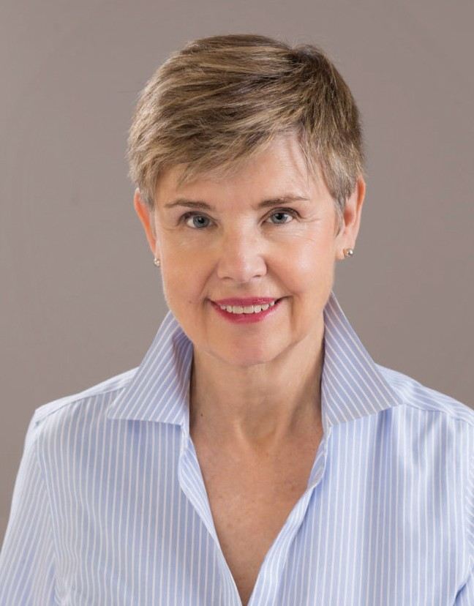

SALLY HELGESEN
HOW WOMEN RISE: HELPING WOMEN REACH
THEIR FULL POTENTIAL

OCTOBER 28, 2020 | 8:30 A.M. – 4:30 P.M.
Sally Helgesen draws from her recent bestseller, How Women Rise, co-authored with legendary executive coach Marshall Goldsmith, which identifies the habits or behaviors most likely to get in the way of successful women. Most of these behaviors are rooted in strengths that may have served women well earlier in their careers, but can undermine them as they assume more responsibility and scope.
Everyone has self-limiting behaviors, for the simple reason that we are all human. Women often face very different challenges as they seek to advance in their careers and operate
on a bigger playing field, so it makes sense that women would adapt their behavior in different ways. These differences in turn shape their expectations of what behaviors will be effective.
Knowing how to spot these habits is helpful for women in their careers, but is also essential for both women and men seeking to become more effective leaders, mentors, coaches, and champions for talented women. Open conversation about these habits and behaviors can be a powerful spur for organizations seeking to encourage more inclusive behaviors. This program will not only bring these habits to the forefront, but provide men and women ways to practically address.

This program will help leaders:
- Identify the habits that most frequently hold women back from reaching their full potential.
- Understand actionable practices that men and women can take with them in order to become more effective leaders and enlist one another as allies in one another’s development.
- Utilize and implement actionable skills through practice and application.
Competencies Addressed: Developing Talent, Drives Engagement, Self-Development, Values Differences, Organizational Savvy
SALLY HELGESEN
Sally Helgesen is cited in Forbes as the world’s premier expert on women’s leadership and is a best-selling author, speaker, and leadership coach. She has been named Number 18 on the Global Gurus list of top leadership experts and selected as MEECO’s International Thought Leader in Cultural Transformation for 2019. Since the publication of The Female Advantage, in 1990, she has written five books in the field of women’s leadership and inclusive leadership. Her most recent book, How Women Rise, co-authored with Marshall Goldsmith, examines the behaviors most likely to get in the way of successful women as they seek to move to a higher level. Sally has consulted with the UN on building more inclusive country offices in Africa and Asia, led programs at Harvard and Smith College, and been visiting scholar at Northwestern University, U-Nordic Stockholm, and the Lauriston Institute Melbourne AU. She is a contributing editor for Strategy + Business magazine and a member of the MG Top 100 Coaches Network and the New York and International Women’s Forums.

RICHARD HADDEN
THE REALITY ABOUT EMPLOYEE ENGAGEMENT
AND YOUR BOTTOM LINE

NOVEMBER 17, 2020 | 8:30 A.M. – 4:30 P.M.

Creating an exceptional place to work is one of the best things you as a leader (or your competitors) can do for your bottom line. While this is probably not surprising to hear, why are some leaders and organizations so great at it and why do some find it to be such a struggle? A key component of an exceptional place to work is engaged employees.

As leaders examine their current employee make-up there should be a strong emphasis on their recruitment process in order to bring in the best workforce possible along with retaining those employees. This program will cause leaders to take a hard look at their people practices and ask… Are we attracting talent? Are we really doing what we should to get sustained peak performance from our multigenerational workforce? Are our people committed? Have we enabled them to do their best work? Do they know we care? Does any of this matter?

In this entertaining and interactive experience, Richard Hadden, will teach you practical techniques that you can take back and start using immediately in getting your employees committed to the mission, enabling them to perform at an elite level, and showing them that you care about them as people. But, the learning and application will not stop there as you will get more than a dozen very specific “assignments” — things you can apply right away to attract better talent, retain your staff, and perhaps most important, increase the willing contribution each employee makes to your organization’s success.

This program will help leaders:
- Learn how to get your employees committed to the mission of your organization.
- Understand the bottom line connection between people practices and profit performance.
- Implement game changing practices that will attract, inspire, engage, and retain your employees of all generations
Competencies Addressed: Attract Top Talent, Builds Effective Teams, Developing Talent, Drives Engagement, Drives Results
RICHARD HADDEN
Richard Hadden is a Certified Speaking Professional, author, and leadership consultant who focuses on the connection between people and profit. He is the co-author of the popular Contented Cows leadership book series, including his latest book, Contented Cows Still Give Better Milk, and the book Rebooting Leadership. Richard has appeared on CNN and MSNBC, and his work has been featured in Bloomberg BusinessWeek, Entrepreneur, and Inc. magazines, as well as in many trade and professional publications.

