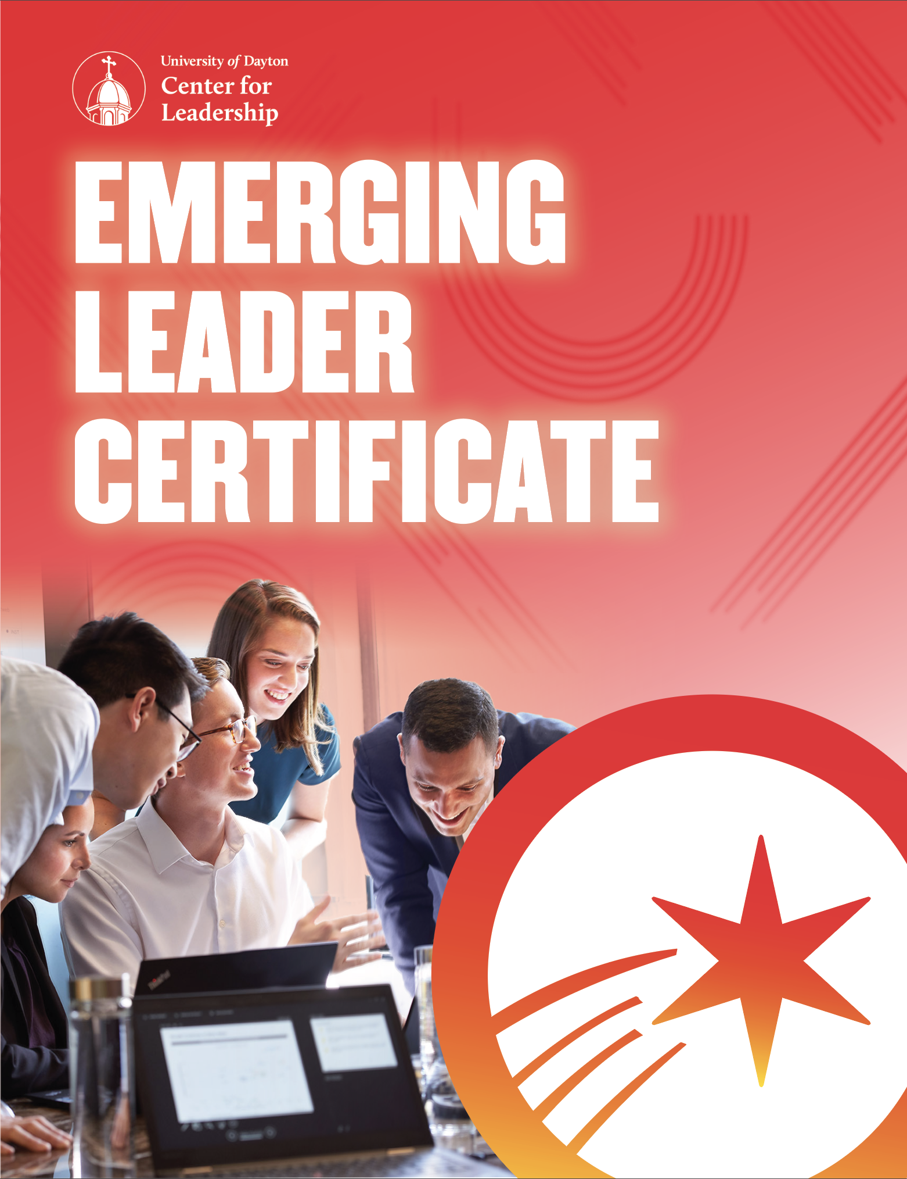

Date | Program
1/19 | Orientation & Using Personality Type and Styles to Foster Leadership
2/1 | Achieving Greater Outcomes – Leading with Intention & Purpose
2/16 | AM: Mentor Training
3/9 | AM: Executive Communication I: Building Your Business Image through Networking, Dining & Etiquette  PM: Executive Communication II: Elevating Your Executive Presence and Personal Brand
4/5 | Coaching For Performance
4/26 | Creating a Great Workplace Culture
5/17 | Leading Community Collaboration (COPE)
6/7 | Learn, Lead & Serve
6/29 | Executive Effectiveness: Functioning at your Full Capacity
7/19-21 | The Leadership Challenge
8/16 | Leading Change
9/13 | Accounting Fundamentals: Finance for Non-Financial Managers I
9/29 | Finance for Non-Financial Managers II
10/12 | Marketing Essentials
11/3 | Operations Management
11/16 | Strategic Management
12/6-7 | Business Simulation
JANUARY 2022

Date | Program
8/10 | Orientation & Using Personality Type and Styles to Foster Leadership
8/30 | AM: Mentor Training
9/21 | Achieving Greater Outcomes – Leading with Intention & Purpose
10/4 | Creating a Great Workplace Culture
11/1 | AM: Executive Communication I: Building Your Business Image through Networking, Dining & Etiquette  PM: Executive Communication II: Elevating Your Executive Presence and Personal Brand
12/14 | Coaching for Performance
1/19/23 | Leading Community Collaboration (COPE)
2/7/23 | Learn, Lead & Serve
2/23/23 | Executive Effectiveness: Functioning at your Full Capacity
3/14-16/23 | The Leadership Challenge
4/5/23 | Strategic Management
4/27/23 | Accounting Fundamentals: Finance for Non-Financial Managers I
5/18/23 | Finance for Non-Financial Managers II
6/6/23 | Marketing Essentials
6/22/23 | Operations Management
7/11/23 | Leading Change
7/26-27/23 | Business Simulation

AUGUST 2022

FACTORS

Every leader has a unique path. Let us be your guide.
Identify the competency or skill you are looking to develop from the list below and find the programs that will address that skill. Program dates and descriptions are listed in detail throughout this document.

Factor I: Thought

Business Insight
- Accounting Fundamentals: Finance for Non- Financial Managers I
- Business Simulation
- Finance for Non-Financial Managers II
- Marketing Essentials
- Operations Management
- Strategic Management

Customer Focus
- Learn, Lead & Serve
- Marketing Essentials

Financial Acumen
- Accounting Fundamentals: Finance for Non- Financial Managers I
- Business Simulation
- Finance for Non-Financial Managers II

Manages Complexity
- Achieving Greater Outcomes: Leading with Intention & Purpose
- Leading Change
- Operations Management
- Strategic Management

Decision Quality
- Accounting Fundamentals: Finance for Non- Financial Managers I
- Achieving Greater Outcomes: Leading with Intention & Purpose
- Business Simulation
- Finance for Non-Financial Managers II
- Operations Management

Balances Stakeholders
- Accounting Fundamentals: Finance for Non- Financial Managers I
- Finance for Non-Financial Managers II
- Leading Change
- Marketing Essentials

Cultivate Innovation
- Strategic Management

Strategic Mindset
- Finance for Non-Financial Managers II
- Strategic Management

Factor II: Results

Resourcefulness
- Business Simulation
- Leading Community Collaboration
- Learn, Lead & Serve
- Operations Management
- Executive Communication l: Building Your Business Image through Networking, Dining, & Etiquette
- Executive Communication ll: Elevating your Executive Presence and Personal Brand

Directs Work
- Coaching for Performance

Plans & Aligns
- Business Simulation
- Leading Change
- Strategic Management

Optimizes Work Processes
- Learn, Lead & Serve
- Operations Management

Ensures Accountability
- Achieving Greater Outcomes: Leading with Intention & Purpose
- Leading Change

Action Oriented
- Achieving Greater Outcomes: Leading with Intention & Purpose

Drives Results
- Achieving Greater Outcomes: Leading with Intention & Purpose
- Coaching for Performance
- Executive Effectiveness: Key Strategies for Increasing Engagement

Factor III: People

Collaborates
- Coaching for Performance
- Creating a Great Workplace Culture
- Leading Community Collaboration
- The Leadership Challenge

Interpersonal Savvy
- Executive Communication I: Building Your Business Image through Networking, Dining, & Etiquette
- Executive Communication ll: Elevating your Executive Presence and Personal Brand
- Mentor Training
- Orientation: Using Personality Type & Styles to Foster Leadership

Builds Network
- Leading Community Collaboration
- Learn, Lead & Serve
- Mentor Training

Develops Talent
- Coaching for Performance

Values Differences
- Leading Community Collaboration
- Orientation: Using Personality Type & Styles to Foster Leadership

Builds Effective Teams
- Creating a Great Workplace Culture

Communicates Effectively
- Coaching for Performance
- Creating a Great Workplace Culture
- Executive Communication I: Building Your Business Image through Networking, Dining, & Etiquette
- Orientation: Using Personality Type and Styles to Foster Leadership

Drives Engagement
- Creating a Great Workplace Culture
- Mentor Training
- The Leadership Challenge

Organizational Savvy
- Leading Community Collaboration
- Learn, Lead and Serve

Situational Adaptability
- Executive Communication I: Building Your Business Image through Networking, Dining, & Etiquette

Drives Vision & Purpose
- The Leadership Challenge

Persuades
- Executive Communication II: Elevating your Executive Presence and Personal Brand

Factor IV: Self

Courage
- The Leadership Challenge
- Executive Communication ll: Elevating your Executive Presence and Personal Brand

Instills Trust
- Creating a Great Workplace Culture

Demonstrates Self-Awareness
- Executive Effectiveness: Key Strategies for Increasing Engagement
- Mentor Training
- Orientation: Using Personality Type & Styles to Foster Leadership
- The Leadership Challenge

Self-Development
- Executive Communication I: Building Your Business Image through Networking, Dining, & Etiquette
- Executive Communication II: Elevating your Executive Presence and Personal Brand
- Executive Effectiveness: Key Strategies for Increasing Engagement
- Mentor Training
- Orientation: Using Personality Type and Styles to Foster Leadership

Being Resilient
- Executive Effectiveness: Key Strategies for Increasing Engagement
- Leading Change

PROGRAM DESCRIPTIONS

Orientation & Using Personality Type and Styles To Foster Leadership

Jan. 19, 2022 | Aug. 10, 2022 9:00 A.M.–4:00 P.M.
This program introduces leaders to the Emerging Leader Program and lays the foundation for a year-long commitment to leadership development. The morning session features an overview of the program, including the program guidelines, curriculum, assessments, mentoring, and coaching. Leaders will also spend the majority of the session learning about their personality types using the Myers-Briggs Type Indicator® (MBTI). The MBTI® assessment is a tool to learn more about how you receive and direct energy, take in information, process information, and view the outside world. This information provides leaders a better understanding of self, those they work with, how to work with others more effectively, and overall enhance who they are as leaders. Specifically, leaders will complete the MBTI® Global Step II™ assessment for the program and use the results as a foundation for better understanding the leader they are and want to become.
This program will help leaders:
• Comprehend the components of "type" and hone leadership skills through a better understanding of one’s "type."
• Identify how personality type affects leadership behavior and communication style.
• Use "type" to enhance problem-solving skills.
Competencies addressed: Communicates Effectively, Demonstrates Self-Awareness, Interpersonal Savvy, Self-Development, Values Differences

Achieving Greater Outcomes – Leading with Intention & Purpose
Feb. 1, 2022 | Sept. 21, 2022 9:00 A.M.–4:00 P.M.
As leaders, we experience many Events each day in which we would like a certain Outcome. However, the Outcome for any Event is not usually set in stone. So, what causes some leaders to excel in these Events and what causes others to flounder? Quite simply, it is the leader’s Response. Yes, the key to producing better outcomes is not the events or situations you encounter, but how you choose to respond. It’s called the R-Factor. This program will provide you the foundation and mechanics to step up to the challenges leaders face in their organization and in their life to identify the Response required in order to achieve improved Outcomes.

This program will help leaders:
- Understand and utilize an intentional and purposeful framework, E+R=O, to positively impact results.
- Learn and apply six disciplines into your professional and personal life to better influence outcomes.
- Develop and implement a 30-day action plan to assist you in becoming a better leader.
Competencies addressed: Drives Results, Ensures Accountability, Decision Quality, Manages Complexity, Action Oriented

Mentor Training
Feb. 16, 2022 | Aug. 30, 2022 9:00 A.M.–12:00 P.M.
This session offers critical training for both emerging leaders and mentors to help start the mentoring relationship on the right track. Emerging leaders and their mentors attend this session together and leave with a better understanding of what formal mentoring truly entails. Using a unique process that identifies and leverages preferred styles of mentoring, we help you clearly define your unique mentoring relationship. Emerging leaders and mentors collaboratively outline the expectations and guidelines for how to best work together during the next year to foster the development of both emerging leaders and mentors.

This program will help leaders:
- Recognize the differences between formal and informal mentoring.
- Assess their preferred mentoring styles and the styles of your partner.
- Understand and practice four different styles of mentoring and their uses.
Competencies addressed: Builds Network, Drives Engagement, Demonstrates Self-Awareness, Interpersonal Savvy, Self-Development

Executive Communication I: Building Your Business Image through Networking,
Dining & Etiquette
March 9, 2022 | Nov. 1, 2022 9:00 A.M.–12:45 P.M.
Confidence comes from knowing that you are presenting yourself in an appropriate manner to leave your desired impression on others. In this workshop, you'll define the impression you wish to leave (i.e. your personal brand) and learn how business etiquette can support maintaining that image when dining, networking and communicating with others.

This program will help leaders:
- Learn how creating a personal brand and using business etiquette will help harness the power that comes from a positive first impression whether it’s made in person, virtually, or through networking.
- Learn modern business etiquette for communication skills including verbal, nonverbal, and electronic communication.
- Learn to confidently navigate networking and business dining situations.
Competencies addressed: Communicates Effectively, Resourcefulness, Interpersonal Savvy, Self-Development, Situational Adaptability

Executive Communication II: Elevating Your Executive Presence and Personal Brand
March 9, 2022 | Nov. 1, 2022 1:00 P.M.–4:00 P.M.
When you elevate your executive presence, you unlock the ability to project mature self-confidence in a variety of workplace situations. From speaking up in a meeting, to presenting in front of a group, to giving critical feedback, having a strong executive presence makes you more effective and influential. In this class, we clearly define executive presence, walk you through a process of discovering your unique EP, and uncover strategies to mindfully use EP in your day-to-day work to accomplish your goals and reach your desired outcomes.

This program will help leaders:
- Learn the definition and characteristics of Executive Presence by reviewing examples.
- Uncover or reaffirm your personal brand and your leadership brand.
- Learn the four indicators of Executive Presence: how you show up, visibility within the organization, how to engage and lead and business acumen.
Competencies addressed: Persuades, Resourcefulness, Interpersonal Savvy, Courage, Self-Development

Coaching For Performance
April 5, 2022 | Dec. 14, 2022 9:00 A.M.–4:00 P.M.
Success in today’s business environment depends on having an engaged workforce. This program is designed to prepare leaders to effectively utilize a coaching approach to leadership. Leaders will gain an appreciation for the importance of coaching, learn four key coaching skills, and have an opportunity to apply them in both a developmental and performance coaching scenario.

This program will help leaders:
- Identify the most critical skills to being an effective coach.
- Use an analysis tool to identify the root cause of a situation.
- Demonstrate the coaching process in a performance and developmental coaching situation.
Competencies addressed: Collaborates, Communicate Effectively, Develops Talent, Directs Work, Drives Results

Creating A Great Workplace Culture
April 26, 2022 | Oct. 4, 2022 9:00 A.M.–4:00 P.M.
Many leaders are intrigued by the creative, productive workplace environments at companies such as Google, Microsoft, and FedEx, yet struggle with how to get there. In this program, participants will learn about the concept of a great workplace; one where employees trust the people they work for, take pride in what they do and enjoy the people they work with.

This program will help leaders:
- Understand the key dimensions of creating a great place to work to develop a competitive business advantage.
- Identify techniques to build trust, pride, and camaraderie deliberately and consistently throughout an organization.
- Understand the key roles leaders have in creating a great workplace and analyze the effectiveness of current management practices.
Competencies addressed: Builds Effective Teams, Collaborates, Communicate Effectively, Drives Engagement, Instills Trust

Leading Community Collaboration (COPE)
May 17, 2022 | Jan. 19, 2023 9:00 A.M.–4:00 P.M.
The morning session will explore principles and practices for effective community leadership. The program will have participants analyze how leadership skills from the three types of organizations (nonprofit, for profit and government) can be blended to create a community leadership style. The session will conclude with practical steps emerging leaders can take to implement these changes. The afternoon kicks off with a poverty simulation allowing you to gain a glimpse into the lives and families living in our community followed by an extensive debrief.

This program will help leaders:
- Explore the principles and practices for effective community leadership.
- Engage in an interactive poverty simulation to assist in understanding the challenges and decision points for the low- income segment of our population.
- Learn about and choose a project for the Learn, Lead, and Serve Program.
Competencies addressed: Builds Network, Collaborates, Organizational Savvy, Resourcefulness, Values Differences

Learn, Lead & Serve
June 7, 2022 | Feb. 7, 2023 9:00 A.M.–4:00 P.M.
A leader’s responsibility to make a difference extends beyond his or her professional life and into the community. This program will explore opportunities for leaders to demonstrate their ability to lead in the community. Emerging leaders will spend one day not only putting their newly honed leadership skills to work, but also serving the Dayton community and making a difference.

This program will help leaders:
- Better understand the similarities and differences between leading professionally and in the community.
- Explore their personal commitment to leadership and community service and evaluate their importance.
- Put leadership skills to work while making a difference in the community.
Competencies addressed: Builds Network, Customer Focus, Organizational Savvy, Optimizes Work Processes, Resourcefulness

Executive Effectiveness: Functioning at your Full Capacity
June 29, 2022 | Feb. 23, 2023 9:00 A.M.–4:00 P.M.
In many organizations, assuming a formal leadership role increases professional demand in a way that makes it difficult to prioritize personal wellbeing and maintain balance. There is pressure to do more and be plugged in 24/7. The research is clear that individual wellbeing, work performance and organizational outcomes improve when leaders learn to take charge of their physical, mental and emotional energy in the midst of this demand. This rich, interactive and inspiring workshop helps existing or rising leaders understand that self-care is not a luxury, but rather an absolute necessity for showing up as the best leader they can be and for maintaining high-performance without burnout. It offers new insights that help leaders re-contextualize their own well-being as an essential business imperative and provides realistic strategies for increasing physical, emotional and mental energy.

This program will help leaders:
- Understand the connection between personal energy management and organizational outcomes.
- Learn and practice strategies that improve physical energy.
- Learn and practice strategies that improve mental and emotional energy.
Competencies addressed: Being Resilient, Demonstrates Self-Awareness, Drives Results, Self-Development

The Leadership Challenge
July 19–21, 2022 | March 14-16, 2023 9:00 A.M.–4:00 P.M.
Today’s most successful organizations are creatively adapting to change by encouraging leadership at every level of the organization. This program is based on the award-winning book The Leadership Challenge and the acclaimed management workshop based on its research. Participants gain confidence and skills by completing The Leadership Practices Inventory (LPI) and using The Five Practices of Exemplary Leadership on the job.

This program will help leaders:
- Recognize how leadership is key to their ability to succeed in challenging situations.
- Identify their leadership strengths and areas for improvement.
- Understand and implement the Five Practices of Exemplary Leadership on the job: Model the Way, Inspire a Shared Vision, Challenge the Process, Enable Others to Act, and Encourage the Heart.
Competencies addressed: Collaborates, Courage, Demonstrates Self-Awareness, Drives Engagement, Drive Vision & Purpose
Leading Change
August 16, 2022 | July 11, 2023 9:00 A.M.–4:00 P.M.
How does the human brain deal with change? As a leader, you are responsible for successfully leading yourself and your team through organizational change along with helping your direct reports further develop their change adaptation capabilities. This program will deepen your understanding of what the brain needs to adapt effectively to change, and will increase your skills in three areas: personally adapting to change, leading others through change, and building/increasing change adaptation competence.
This program will help leaders:
• Understand the human brain’s natural reactions to significant change.
• Deepen awareness of effective change leadership tactics.
• Recognize the primary keys to being consciously change resilient.
Competencies addressed: Balances Stakeholders, Being Resilient, Ensures Accountability, Manages Complexity, Plans & Aligns

Accounting Fundamentals: Finance For Non-Financial Managers I
Sept. 13, 2022 | April 27, 2023 9:00 A.M.–3:00 P.M.
Leaders will learn how to understand a firm’s financial statements, including how each of these statements is prepared in accordance with generally accepted accounting principles and how these statements provide crucial information about the firm. This basic understanding will also help leaders measure financial performance, critically assess information and make more effective business decisions. Finally, leaders will leave this session feeling more prepared to explore the financial concepts presented in the Finance for Non-Financial Managers II program.

This program will help leaders:
- Understand key accounting concepts.
- Read and interpret key financial statements.
- Understand financial implications of business decisions.
Competencies addressed: Balances Stakeholders, Business Insights, Decision Quality, Financial Acumen

Finance for Non-Financial Managers II
Sept. 29, 2022 | May 18, 2023 9:00 A.M.–4:00 P.M.
Using a case study approach, this session focuses on understanding key financial indicators and gives insight into both the causes and the consequences of weak financial performance. Having an understanding of these concepts will allow you to be better prepared to lead your organization from a financial perspective. Participants leave with a heightened understanding of the financial environment, measures of financial health and decision-making models and they will derive a greater awareness of the various stakeholder relationships that are at issue in organizations.

This program will help leaders:
- Understand the difference between Accounting and Finance.
- Become familiar with the fundamental concepts of Corporate Finance and Financial Management.
- Learn to use financial tools such as Break Even Analysis and Financial Ratios.
Competencies addressed: Balances Stakeholders, Business Insight, Decision Quality, Financial Acumen, Strategic Mindset

Marketing Essentials
Oct. 12, 2022 | June 6, 2023 9:00 A.M.–4:00 P.M.
This program highlights the essential elements of successful marketing strategies and the critical issues facing marketing leaders today. Using small group discussion, participants conduct market and customer analyses of an organization to identify competitive advantages and generate ideas to increase sales and profits. Participants will learn customer segmentation, brand positioning, the marketing mix, marketing channels, the marketing funnel, customer experience, and leveraging digital and social media. Additionally, participants will explore potential strategies and discuss how to apply key learnings and frameworks to participant organizations to drive positive ROI.
This program will help leaders:
• Understand the market positioning of a firm and the relationship of marketing with other functional areas of the organization.
• Apply marketing strategies and frameworks.
• Learn strategies to drive awareness, acquire new customers, enable consideration, conversion, and retain loyal customers to drive growth for organizations.
Competencies addressed: Balances Stakeholders, Business Insight, Customer Focus
Operations Management
Nov. 3, 2022 | June 22, 2023 9:00 A.M.–4:00 P.M.
This workshop focuses on the strategies and techniques of business processes and supply chain management for ensuring superior operational and overall performance. Topics include operations and business processes, improvement approaches and tools, extending from single-organization operations to supply chain management. Leaders will leave this program with a better understanding and appreciation of operations management. The impact that operations have on an organization can be tremendous, so understanding how it works plays an important role within leadership.

This program will help leaders:
- Understand commonly used Operations tools and processes.
- Recognize how Operations helps bring products and services to customers.
- Appreciate how Operations tools and processes make us more efficient and reduce our cost structures.
Competencies addressed: Business Insight, Decision Quality, Manages Complexity, Optimizes Work Processes, Resourcefulness

Strategic Management
Nov. 16, 2022 | April 5, 2023 9:00 A.M.–4:00 P.M.
In today’s rapidly changing business environment, business leaders must be proactive, anticipate the unexpected and continually refine their firm’s strategy in order to remain successful. This session is designed to give emerging leaders the analysis tools and thought processes needed to help an organization achieve profitable, sustainable growth. Attendees complete a case analysis, which serves as a basis for discussion. Participants learn to identify key industry success factors, determine a firm’s core competencies and build strategic business processes that foster top-line growth for bottom-line results.

This program will help leaders:
- Understand how firms/organizations develop strategies (mission, vision, values) and when various strategies are appropriate.
- Understand the resource-based view of the firm and identify the four criteria (VRIO framework) that a firm’s resources must possess to maintain a sustainable advantage.
- Understand the impact of external forces, including the PESTEL model, industry dynamics, and strategic groups.
Competencies addressed: Business Insight, Cultivate Innovation, Manages Complexity, Plans and Aligns, Strategic Mindset

Business Simulation
Dec. 6-7, 2022 | July 26-27, 2023 9:00 A.M.–4:00 P.M.
During this business simulation, participants work in teams to plan and implement company operations on an annual basis. Each team functions as a knowledge service organization and competes with other teams for knowledge, workers, and customers. All companies start out on equal terms and are able at all times to observe the consequences of each other’s decisions. At the end of each “year,” participants calculate the financial performance of the organization, as well as their alignment between levels of manpower and customer projects. This program will test your business skills and put into application what you have learned in the emerging leader program to date.
This program will help leaders:
• “Run an organization” from a management or executive perspective.
• Integrate the various business and leadership skills learned throughout the emerging leader program.
• Lead and work cooperatively in a team environment.
Competencies addressed: Business Insight, Decision Quality, Financial Acumen, Plans & Aligns, Resourcefulness

