Higher SET Completion Rates in the Classroom

David J. Wright, May 5, 2017

Are the participation rates of students completing SET surveys higher when conducted in the classroom?

Methods
SET participation rates and survey completion dates for fall 2016 semester was extracted from CoursEval in a way that removed all instructor names or section numbers. The data had no personally identifiable information for students or instructors. 1,102 sections were identified from the dataset with rosters containing 20 or more students. The remaining 1,235 sections were excluded because with small sections (<20 students) it is difficult to see a peak completion rate against the background.
To identify sections in which students were required to complete SET in the classroom, the peak fraction of the roster that completed the survey within any 2 hour window was identified and expressed as a fraction of completion for the entire 10 day period the survey was open (11/29-12/9). An arbitrary cut-off was set for those sections that were done in the classroom (A in graph) where peak fraction was >= 50% and outside the classroom (B in graph) where peak fraction was < 50%).
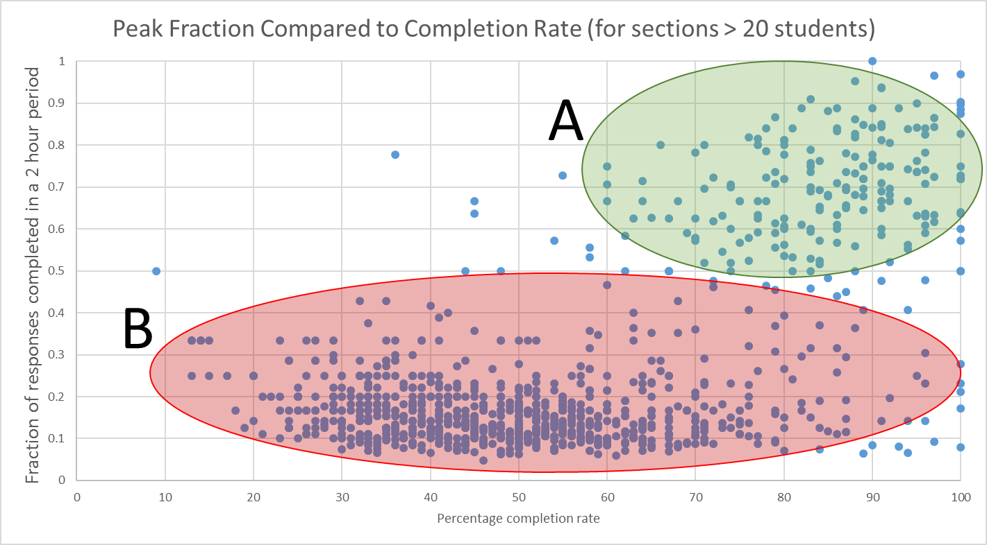

Results
In the classroom (A), the average completion rate was 82.85% (SD ± 13.48%).
Outside the classroom (B), the average completion rate was 49.40% (SD ± 16.16%).
Although somewhat arbitrary, the 50% cutoff point demonstrates two populations of course sections - a smaller group of 200 sections (5,027 students) with presumed in-classroom completion of SET and a larger group of 902 sections (14,749 students) completed outside the classroom. For this larger (B) group of sections, instructors are choosing not to complete the surveys in the classroom, are unable to complete the surveys in the classroom, or the students fail to comply with requests to complete SET in the classroom.

